Magnitogorsk.
A visit to the theatre.

В данном сборнике представлены дидактические материалы регионоведческого характера, соответствующие федеральному государственному стандарту основного общего образования в рамках национальных, регтональных и этнокультурных особенностей.
Содержательной основой упражнений сборника является информация о культурной жизни города Магнитогорска, а именно о театре. Ряд представленных заданий соответствует формату ОГЭ и ЕГЭ, что может способствовать подготовке учащихся к сдаче данных экзаменов.
Пособие предназначено для учащихся старших классов школ, гимназий и лицеев. Пособие можно использовать на занятиях в классе, а также при подготовке к ЕГЭ/ОГЭ или к олимпиаде по английскому языку.

Составитель: Р.Ш. Соболева, методист МУ ДПО «ЦПКИМР».
Авторы: Бахтина А.Г., Леушкина О.В., Омеленчук Э.Ф., Омеленчук К.В., Панова М.А., Серова Е.М, Соболева Р.Ш., Чурилова А.П.
Рецензент: И.Р.Пулеха, кандидат филологических наук, доцент кафедры английского языка Института гуманитарного образования ФГБОУ ВО «МГТУ им. Г. И. Носова»

Муниципальное учреждение
дополнительного профессионального образования
«Центр повышения квалификации и информационно-
Методической работы» г.Магнитогорска

Сборник
Учебно-тренировочных материалов
«Magnitogorsk. A Visit to the Theatre»

Магнитогорск
2019
Цель данного пособия-познакомить учителей и учащихся с дополнительным материалом по теме «Театр», который поможет учащимся расширить свой лексический запас по данной теме. Кроме того, ряд заданий представлен в формате ОГЭ и ЕГЭ, чтодаёт возможность использовать данный сборник для подготовки к экзамену. Пособие может использоваться как для занятий в группе, так и для индивидуальной подготовки. Задания пособия способствуют формированию лексико-грамматических навыков, а также навыков устной речи и дают возможность выразить собственное отношение к культурной жизни города Магнитогорска. Сборник содержит:
- вокабуляр по теме «Театр»
- тексты с упражнениями
- диалоги с упражнениями
- задание 2 раздела «Говорения» ЕГЭ- где предлагается ознакомиться с рекламным объявлением изадать 5 вопросов на основе ключевых слов. Время на подготовку-1,5 минуты. Время отведённое на каждый задаваемый вопрос, не более 40 секунд.
- Правило написания рецензии.

USEFUL VOCABULARY “THEATRE” [2]
Theatre, kinds of theatres – виды театров
Opera House – Opera and Ballet theatre – оперный театр
Drama theatre – драматический театр
Musical Comedy theatre – театр музыкальной комедии
Young People's theatre – театр для молодежи
Children's theatre – театр юного зрителя
Variety theatre – эстрадный театр
Puppet theatre - кукольный театр
Conservatoire –консерватория
Philharmonic Society – филармония
Concert Hall – концертный зал
Circus – цирк
Carnival, fancy-ball – карнавал
Amateur theatre – самодеятельный театр
Fringe theatre – авангардный театр
Types of plays – виды пьес
Tragedy – трагедия
Comedy – комедия
Tragi-comedy – трагикомедия
Farce – фарс
Drama / straight play (non-formal) – драма
Historical play / drama – историческая драма
Musical – мюзикл
Thriller – триллер
Vaudeville / a comic sketch with songs – водевиль
Operetta – оперетта
Musical comedy – музыкальная комедия
Ballet – балет
Opera –опера
Script – либретто, сценарий
Play – пьеса
Box-office play – "кассовая" пьеса
Repertoire – репертуар
Concert – концерт
Buying tickets – покупка билетов
Box-office – касса
Ticket agency – межтеатральные билетные кассы
To buy tickets at the box-office / at a ticket agency – покупать билеты в кассе
To buy / to reserve tickets in advance – покупать / бронировать билеты заранее
To reserve tickets by phone – бронировать / заказывать билеты по телефону
To line (AmE) / to queue (BrE) for returns – стоять в очереди за оставшимися или возвращаемыми билетами
Standing ticket / room – входной билет (без места)
Complimentary ticket – пригласительный билет (free ticket given, for example, to theatre critics of newspapers)
House seats – the seats kept for leading actors to invite anyone they wish
Extra ticket – 'лишний' билет
To buy tickets for the theatre – покупать билет в театр
To buy / get tickets for King Lear – покупать билет на Короля Лира
To buy / get tickets for Sunday – покупать билет на воскресенье
Seating plan – план зрительного зала
"House full" – все билеты проданы (объявление)
Box-office returns – кассовые сборы
To be on – идти (о пьесе, фильме в определенный день)
e.g. A new play is on at the Drama theatre tonight.
To run – демонстрировать, показывать (какой-то период)
e.g. We've been running this comedy for 3 months.
Poster / Bill-board (AmE) – афиша
Theatre inside, the building and the services
Foyer / lobby / crush room – фойе
Cloakroom – гардероб
Opera glasses – театральный бинокль
Programme – программа
Refreshment room - буфет
Buffet / bar – буфет
Auditorium / house – зрительный зал
Full house – полный зал
Stalls – партер
Pit / parquet circle – амфитеатр
Dress circle / (AmE) balcony, mezzanine – бельэтаж
Box, in the box – ложа, в ложе
Orchestra stalls - первые ряды партера
in the orchestra ~ – в первых рядах партера
Balcony – балкон
in / on the ~ на балконе
Upper circle – первый ярус
Tier [tıə] – ярус
Gallery / "the gods" – галерка
Row – ряд
on the front ~ в первом ряду
on the back ~ в последнем ряду
in the fifth row – в пятом ряду
Seat – м1есто
Aisle [1aıl] - проход между рядами
Stage – сцена
Revolving stage – вращающаяся сцена
Proscenium – авансцена
Orchestra pit – оркестровая яма
Curtain – занавес
draw ~ - раздвигающийся в стороны ~
fly ~ - поднимающийся вверх ~
tableau ~ (bunching up sideways – вверх и в стороны раздвигающийся ~)
Wings – кулисы
from behind the wings – из-за кулис
e.g. She came out from behind the wings. – Она вышла из-за кулис.
Footlights – рампа
Prompter box – суфлерская будка
Spot / spotlight – лампа – софит
Property department – отдел реквизита
Catwalk (bridge) – мостки над сценой (для управления лампами, декорациями и для сценических эффектов)
Scenery – декорации
Set – декорация к определенной сцене
Backcloth / backdrop / background – задник
Property / furnishings – реквизит
Performances - спектакли
To cast – выбирать актеров на роли
To act / to appear / to be in / to perform / to play
To act – to perform in a play, especially as a job
To appear / to be in – to act in a particular play.
To perform a play / to pantomime – to act in it for people to watch.
To play – to act as a particular character in a play
To star / to co-star / to play the lead (the leading / title role) – to be the main actor in a play
Leading part / title role – главная роль
Supporting part / minor role – роль второстепенного персонажа
Cast – состав исполнителей на данный спектакль
First-rate cast – первоклассный состав исполнителей
All-star cast – звездный состав исполнителей
What is performed in the theatre.
Play / production / performance
Play – пьеса
Production – постановка
Performance – спектакль
Act – акт
Scene – сцена
To stage / to put on / to present / to direct / to do the play
To stage / to put on a play – ставить пьесу
To present a play - представить пьесу
To direct a play –ставить спектакль
Rehearsal – репетиция
Dress rehearsal – генеральная репетиция
Behind the scenes, behind the wings - за кулисами
First appearance – дебют
Matinée - утренний спектакль
First night / premiere – премьера
Curtain (rises up, falls ) – занавес (поднимается, опускается)
Lights (go down, go up) – свет (гаснет, зажигается)
Crowd scenes – массовые сцены
Curtain call – вызов актеров на сцену публикой (после спектакля)
Encore [a:ŋ'kɔ:] – вызов на бис
People watching the production
Spectator – зритель
Audience (AmE countable, BrE uncountable) – публика, зрительская аудитория
Public – публика
Theatre-goer / theatre-enthusiast / theatre lover – театрал
Critic – критик
Touring company – гастролирующая труппа
Summer tour – летние гастроли
To applaud – аплодировать
Applause – аплодисменты
Storm of applause – буря аплодисментов
To burst into applause – взорваться аплодисментами
To clap – хлопать
To be a success with the public – иметь успех у публики
To be a complete failure – полный провал
To be a hit of the season – 'гвоздь сезона'
To be a flop – провал, не оправдавший ожиданий
To have a successful run – иметь успешный прокат
To have a long run – (пьеса) долго идет
Theatrical season is in full swing – Театральный сезон в полном разгаре.
People in the theatre – люди в театре
Company – труппа
Permanent staff – постоянная труппа
Actor / actress – актер / актриса
Honoured actor / actress of Russia – заслуженный артист(ка) России
People's actor / actress of Russia – народный артист(ка) России
Comedian – комик
Tragic actor – трагик
Extra – статист
Understudy – дублер
Conductor – дирижер
~'s baton – дирижерская палочка
Singer – певец / певица
Chorister, member of a choir, chorus – хорист
Ballet dancer – балерина / танцор
Corp-de-ballet – кордебалет
Producer – режиссер
Playwright / dramatist – драматург
Director – режиссер
Choreographer – хореограф, балетмейстер
Stage designer – сценограф, оформитель спектакля
Costume designer – художник по костюмам
Technical crew – обслуживающий персонал
Make-up man – гример
Stage-hand / scene shifter - рабочий сцены
Lighting man – осветитель
Prompter – суфлер
Usher – билетер
Attendant – служитель(ница), капельдинер
Make-up – грим
Wig – парик
Costume / theatrical dress – костюм
Tutu – балетная пачка
Ballet shoes – балетные туфли, пуанты
Orchestra - оркестр
Symphonic orchestra – симфонический оркестр
Chamber orchestra – камерный оркестр
Jazz band – джазовый оркестр
Band – духовой оркестр
Conductor – дирижер
Conductor's stand – возвышение для дирижера
Conductor's baton – дирижерская палочка
Score – пюпитр для нот
Leader of an orchestra – Концертмейстер
Tune up – настраивать инструменты
Choir / chorus – хор
Tickets.
How much is the admission? – Сколько стоит входной билет?
What is the lowest admission fee? – Какой самый дешевый билет?
You can't imagine how difficult it is to get tickets. – Вы не представляете себе, как трудно достать билеты.
The house has been sold out long in advance. – Все билеты были распроданы задолго до начала.
I'll make arrangements for Saturday night. - Я закажу билеты на субботу.
It's next to impossible to get tickets for the theatre – Почти невозможно достать билеты в театр.
We might pick up a couple of tickets at the entrance. – Может быть, нам удастся достать два билета у входа.
It is a complimentary ticket that you have? – Это у вас пригласительный билет?
At the cloakroom
Where can we check our things? – Где можно сдать вещи?
What is this check for? – Зачем этот номерок?
Ask the cloakroom attendant for opera-glasses. – Попросите у гардеробщицы театральные бинокли.
Theatre. Seats.
It's a long time since I was at the theatre. – Давненько я не был в театре.
The theatre is crammed. – Театр набит битком.
The theatre is full up to the doors. – Театр полон до отказа.
The house is rather thin today, isn't it? – Театр сегодня полупустой, не правда ли?
The attendant (usher) will show us our seats. – Билетер покажет нам наши места.
Would you mind moving over one seat to the left? – Вы не возражаете против того, чтобы пересесть на соседнее место?
Would you object to exchanging seats? – Вы не возражаете против того, чтобы поменяться местами?
Let's mount to our seats in the balcony. – Давайте поднимемся к нашим местам на балконе.
Beginning. Entr'acte.
I'm eager for the performance to begin, you know. – Знаешь, я с нетерпением жду начала спектакля.
Oh, let's hurry! There goes the last bell. – О, давайте поспешим. Последний звонок звенит.
The entr'acte will be presently. – Сейчас будет антракт.
Will the interval last long? – Долго ли продлится антракт?
Stage. Settings.
They have dimmed the top lights. – Они затемнили прожекторы.
They have a revolving stage there. – Там есть вращающаяся сцена.
No, I have never been behind the wings (scenes). – Нет, я никогда не был за кулисами.
They have a good setting-designer, I should say. – Должна сказать, у них хороший художник-декоратор.
The costumes are said to have been done by Slava Zaitzev himself. – Говорят, костюмы были созданы самим Славой Зайцевым.
They change the sets in no time. – Они мгновенно меняют декорации.
One can't help admiring the scenery in __. – Нельзя не восхищаться декорацией в __.
The scene is laid in the woods (in N's study). – Действие происходит в лесу (в кабинете Н.)
Actors.
It's her first appearance on the stage today. – Сегодня ее дебют на сцене.
She portrayed Masha in … - Она играла Машу в …
He appeared in … sharing the lead with N. – Он выступал в …, где он и Н. играли ведущие роли.
She played the part of … in … - Она играла роль … в …
He has been awarded the title of the Honoured Artist of Russia. – Ему было присвоено звание заслуженного артиста России.
She is the star of the day. – Она звезда.
He quitted the stage long ago. = Он давно уже не играет на сцене.
His sun is set. – Его звезда закатилась.
Who's playing the leading role? – Кто играет ведущую роль?
Who's singing / dancing the part of …? – Кто поет / танцует партию …?
M. is singing the part of Ivan Susanin and N. – the part of Antonida. – М. поет партию Ивана Сусанина, а Н. – партию Антониды.
He plays one of the minor roles. – Он исполняет какую-то второстепенную роль.
She has only a thinking part in this play. – У нее в этой пьесе роль без слов.
The cast was excellent with the exception of N. – Весь состав исполнителей был хороший, за исключением Н.
They have got an excellent cast tonight. – Сегодня играет превосходный состав.
Impression
The performance is worth seeing – Спектакль стоит посмотреть.
I was completely carried away by the acting. – Я была полностью захвачена действием.
I enjoyed the play very much. – Я получил большое наслаждение от пьесы.
I enjoyed every minute (bit) of it. – Я наслаждался ею от начала до конца.
I've never seen anything half so splendid. – Я никогда не видел ничего более прекрасного.
I was deeply impressed by the play. – Пьеса произвела на меня глубокое впечатление.
I can hardly put into words what I think of it. – Мне трудно передать словами, что я думаю о ней.
Oh, it's too lovely for words! – О, нет слов, чтобы это описать!
It's a play I'll remember for long. – Это пьеса, которую я долго буду помнить.
I haven't laughed so much for a very long time. – Я давно так не смеялся.
It's too funny for words. – Это так смешно, что трудно передать словами.
She performed her part with conviction and passion. – Она играла свою роль убедительно и с чувством.
The rendering was good. – Исполнение было хорошим.
She really attracts the attention of the public with her play. – Она действительно привлекает внимание публики своей игрой.
The complex and contradictory character of N. is well portrayed by the young actress M. – Сложный и противоречивый образ Н. хорошо передан молодой актрисой М.
Their play makes one forget that they are watching a play. – Глядя на их игру, забываешь, что смотришь спектакль.
His play was so natural that we began to feel for him as in real life. – Его игра была такой естественной, что мы по-настоящему переживали за него.
That is a rather touching scene. – Это довольно трогательная сцена.
The grace of her movements was the delight to the eye. – Ее грациозные движения радовали глаз.
As soon as she began to dance she captivated everybody. – Как только она начала танцевать, она очаровала всех.
There was no end to the applause when the play was over. – Не было конца аплодисментам, когда представление окончилось.
The admiration of the public knew no bounds. – Восхищение публики не знало границ.
They were strewn with flowers. – Они были засыпаны цветами.
Her success was beyond all expectations (exceeded all hopes). – Ее успех превзошел все ожидания.
The spectators clapped and cheered. – Зрители хлопали и восторженно кричали.
Many of the pieces were encored by a most enthusiastic audience. – Многие номера были повторены на бис по требованию восторженной публики.
Curtain call followed curtain call. – Вызов следовал за вызовом.
The lines were simply spoken. – Он просто читал свою роль.
It was dull to the extreme to listen to her. – Было до крайности скучно ее слушать.
The audience was irritated. – Публика была раздражена.
She could have done better. – Она могла бы сыграть лучше.
Не overacts sometimes. – Он иногда переигрывает.

Theatre inside. [1]

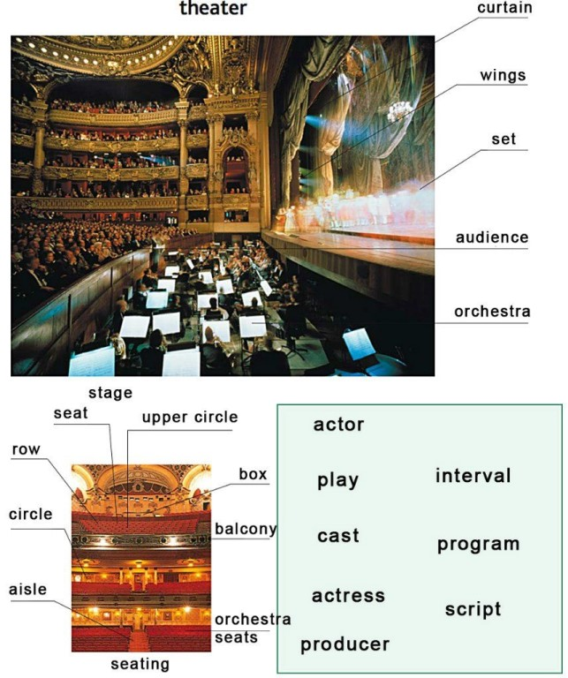

A visit to the theatre

I’m not a theatre-goer, you know. Most teenagers prefer cinema to theatre. So do I. But it happened so, that I visited our local drama theatre. I went to the theatre with my granny a month ago. She likes to watch musical comedies very much. She decided to watch the play “Figaro’s marriage” by Pier de Bomarshe. Though we could buy tickets at the box-office, we preferred to reserve tickets in advance. The tickets were not too expensive.
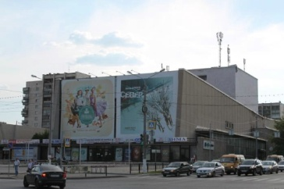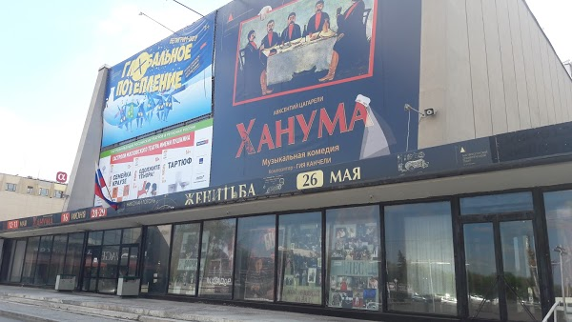
When the day of the performance came, we arrived at the theatre thirty minutes before the play. We left our coats and hats in the cloakroom. In the foyer we bought a programme from the usher. My granny said it would give us the information about the play, the cast and the director. My granny didn’t take opera glasses, because our sits were in the stalls. We could get a good view of the stage from our seats.
The theatre was full up to the doors as all the tickets were sold. There were two bells. All people hurried to take their seats. When the third bell rang, the lights went down, the curtains rose up and the performance began. I looked around. Everybody was deeply involved in what was happening on the stage.

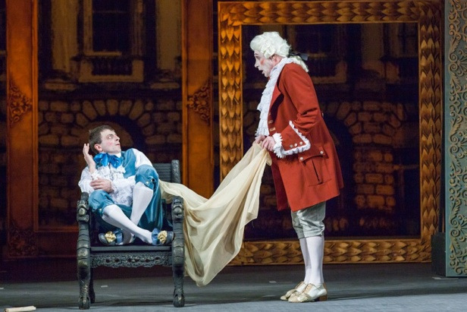 The scenery was wonderful. The cast was first-rate. All the actors and actresses performed their parts with conviction and passion. I was completely carried away by the acting. I hadn't laughed so much for a very long time. The performance lasted for three hours as it had two acts. There was an interval between the acts. The audience had time to rest and to exchange their impressions.
When the performance was over, the lights went up, the curtains fell. The admiration of the public knew no bounds. There was a storm of applause. At that moment I realized that the performance was worth seeing. It changed my attitude to the theatre. Next time I’ll go to the theatre with my friends.

- Using the text, find the English equivalents to the given expressions.

Театрал, я давно так не смеялся, спектакль начался, заказывать билеты заранее, спектакль длился 3 часа, обменяться впечатлениями, декорации были чудесные, местный драматический театр, оставили одежду в гардеробе, купить билеты в кассе, купить программку у капельдинера, в партере, театральный бинокль, восхищение публики не знало границ, билеты были проданы, играли свою роль убедительно и с чувством, изменить отношение к театру, шквал аплодисментов, состав актеров, режиссёр, два действия.

- Say if the statements are True, False or Not Stated
- Most teenagers prefer cinema to theatre.
- I went to the theatre with my classmates a month ago.
- My granny likes to watch musicals very much.
- She decided to watch the play “The Twelfth Night” by W. Shakespeare.
- We reserved tickets in advance.
- When the day of the performance came, we arrived at the theatre fifteen minutes before the play.
- In the foyer we bought opera glasses from the usher.
- We could get a good view of the stage from our seats.
- The theatre was full up to the doors as all the tickets were sold.
- When the third bell rang, the lights went down, the curtains rose up and the performance began.
- The scenery was dull and the cast wasn’t first-rate.
- All the actors and actresses performed their parts with conviction and passion.
- The performance lasted for two hours and a half as it had two acts.
- The public was disappointed with the play.
- There was a storm of applause.
- It changed my attitude to the theatre.

- Fill in the blanks with the words from the box

curtains /in the stalls/ audience /foyer / musical comedies/ cloakroom/ acts/ deeply involved/ cast and director/ applause/ theatre/ drama / reserve tickets /usher /tickets/ actors and actresses/ admiration/

Most teenagers prefer cinema to ___.
I visited our local ___ theatre.
She likes to watch ___ ___ very much.
We preferred to ____ ___ in advance.
We leave our coats and hats in the ___ .
In the ___ we bought a programme from the ___.
My granny said it would give us the information about the play, the ___ ___.
My granny didn’t take opera glasses, because our sits were __ __ .
The theatre was full up to the doors as all the ___were sold.
Everybody was ___ ___ in what happened on the stage.
All ____ _____ performed their parts with conviction and passion.
The performance lasted for three hours as it had two ___.
The ____ had time to rest and to exchange their impressions.
When the performance was over, the lights went up, the ___ rose / fell.
The __ of the public knew no bounds.
There was a storm of ____.

- Put each of the following words or phrases in its place in the passage below. [3]

reviews | performances | audience | rehearsals | run | flop
director | theatregoers | first night | auditions | hit | cast
critics | playwright | matinees | applause | parts | pieces

PRODUCING A PLAY
The person who directs the preparation of a play is the ____ (1) . Sometimes the___(2), who wrote the play, works with him. One of the first things to be done is to choose the____(3), the actors and actresses. For this purpose,___(4) are held at which actors perform short___ (5) and the most suitable are chosen for the ___(6) in the play. Before the play is performed in front of an __(7) of hundreds of ___(8), of course there are a lot of ___(9). At last, the ___(10)! When the curtain goes down at the end, will there be enthusiastic ___(11) or silence? Will the newspaper __(12) be good or bad? What will the___(13) think? Everyone hopes for a___(14) that will ___ (15) for months or even years, but the play might be a ___(16) and only last a few days. It’s hard work in the theatre. There are evening ____(17) six nights a week and afternoon shows, called ___ (18), once or twice as well.

- Match each part of a theatre on the left with a definition on the right.

1. stalls | a. | where actors put on their costumes and make-up
2. aisle | b. | area on which the performance takes place
3. circle | c. | a line of seats
4. dressing room | d. | a way down from back to front between the seats
5. stage | e. | the area of downstairs seats
.6. box office | f. | the area of upstairs seats
7. row | g- | the theatre entrance hall where people meet before going in
8. backstage | h. | the place where you go or phone to buy tickets
9. box | i. | the whole area out of sight of the audience
10. foyer | j- | a little private balcony with 3-5 seats only

- Match the words on the left with a definition on the right.
How much is the admission? | Вы не представляете себе, как трудно достать билеты
What is the lowest admission fee? | Я закажу билеты на субботу.
You can't imagine how difficult it is to get tickets | Может быть, нам удастся достать два билета у входа.
The house has been sold out long in advance | Это у вас пригласительный билет?
The house has been sold out long in advance | Сколько стоит входной билет
It's next to impossible to get tickets for the theatre | Почти невозможно достать билеты в театр.
We might pick up a couple of tickets at the entrance. | Все билеты были распроданы задолго до начала
Is it a complimentary ticket that you have? | Какой самый дешевый билет?
Where can we check our things? | Зачем этот номерок?
What is this check for? | Попросите у гардеробщицы театральные бинокли.
Ask the cloakroom attendant for opera-glasses. | Где можно сдать вещи?

Dialogues [5]
Dialogue №1 At the box office window
Man: May I have 2 tickets for this evening's performance, please?
Cashier: Do you have reservations?
M: No. Are there any good seats left?
C: Yes, I have a few. I can give you very good seats either in the orchestra or in the first balcony, third row.
M: Good. I like the seats in the balcony better than those on the main floor. Give me two, please, on the aisle if possible. Do you have programs here?
C: No. You can get them from the usher at the main entrance.
M: Thank you very much. Good bye!

Say if the statements are True, False, Not stated
They want to buy 2 tickets for today’s performance.
They reserved tickets in advance.
There were seats neither in the orchestra nor in the balcony.
They asked for tickets on the aisle.
The programs are sold by the director at the main entrance.

Dialogue №2

V: Have you got any seats for today’s performance?
A: Matinee or evening performance?
V: Evening, please.
A: How many tickets would you like?
V: Two, please.
A: OK, let me see…
V: I’d like the seats in the stalls, please.
A: Would you like to sit in the middle of the row or in the aisle?
V: I prefer the seats in the middle of the row.
A: You can have two seats in the middle of row E.
V: Well, that’s great! How much are they?
A: four hundred fifty roubles, please.
V: Here is one thousand roubles.
A: Thank you. Here are your tickets and one hundred roubles change.
V: What time does the performance start?
A: At seven p.m. and the doors open at 6.30.
V: Thank you.
A: You’re welcome.

Questions.
- Have they bought tickets for the Matinee or evening performance?
- How many tickets have they bought?
- Where are the seats?
- How much does a ticket cost?
- How much have they paid for two tickets?
- What time does the performance start?

Dialogue №3

K: Thanks God, we aren’t late.
J: I was afraid of being late too.
K: Where are our seats?
J: In the balcony, let’s hurry up.
K: In the balcony? You are kidding! I thought they would be in the stalls.
J: No, our seats are in the balcony, you see, they were the last seats left.
K: You’ve bought the cheapest seats!
J: It was impossible to get other seats; by the way, the view of the stage from the balcony is rather good. We’ll see everything excellently.
K: OK, there’s no use to quarrel in the theatre.
J: Don’t worry. The play is modern and very interesting. You’ll enjoy it.

Read the statements and choose the correct variant to complete the sentence.

Kate and Jack are/aren’t late. They are in a hurry as they like/don’t like to be late. Their seats are in the stalls/in the balcony. They have bought these seats because these seats are the best/ they were the last seats left. The seats are the most expensive/the cheapest. The view of the stage from the balcony is rather good/bad. The play is modern and very interesting/uninteresting.

Dialogue №4

Exchange the underlined words with the words in the box, according to their meaning.

Set, permanent staff , play, fascinating, smart, breathtaking, unbelievable

J: Did you like the performance?
K: Oh, John, it was great! I have forgotten everything. It was so interesting!
J: How did you like the acting of the young actress?
K: She was charming and witty. Her acting is impressing.
J: The cast was excellent today. They are all stars. I’ve got a lot of positive impressions.
K: You’re right, my dear. Did you notice that the scenery was really beautiful?
J: Yes, I did. It was fantastic! Are you still angry with me?
K: No, my dear. I’m very happy!

Dialogue № 5 A Date for the Theatre

Mike Hello, Jack. Do you often go to the theatre?
Jack Yes, Jane and I usually go at least once a month; sometimes more. Do you ever go?
Mike Yes, but I don't often find time these days. There are so many other things to do.
Jack True, true.
Mike Listen, perhaps Ann and I can arrange to meet you and Jane one Saturday evening. We can have dinner together and go to a theatre.
Jack That's a good idea. Look, there's a good play on at the Pushkin Drama theatre next week. If you want, I can book four seats for next Saturday.
Mike All right. I'm meeting Ann later this evening so I can make sure that she's free next Saturday. I'll ring you tomorrow to confirm if we are coming.
Jack Fine. I must hurry now. I must meet Jane.
Mike I'll phone you tomorrow then. Give my regards to Jane. Have a good evening.

Questions.

1. Who goes to the theatre once a month?
2. Why can’t Mike visit theatre very often?
3. Who suggested the idea of going to the theatre together ?
4. What theatre have they chosen?
5. Are they going to buy tickets at the box-office?

EXERCISE №1
Arrange the following sentences logically to make up a dialogue between a correspondent of a local newspaper and two friends after watching the play “Groza (Thunderstorm)” in Magnitogorsk Pushkin Drama Theatre. Put the letter C (for correspondent) and F1, F2 (for the friends).

- Excuse me, can you help me?
- What’s so special about the play?
- Didn’t you know that “Thunderstorm” received the national theatrical award “Gold Mask” in 2008?
- Yes…
- We’ll be happy to help you.
- You won’t regret. Apart from the plot, the acting in this performance is brilliant.
- Oh… thank you very much for the help. It was a great pleasure to speak to you.
- Thanks. So… did you like the performance actually?
- I’m writing an article for the local newspaper and collecting the information about the play “Thunderstorm”.
- Do you mean you want to interview us?
- Thank you. Good bye.
- You know, I’ve never thought a small theatre like our Pushkin Drama theatre can perform such an outstanding play!
- Really? Well, to my mind it deserves it.
- Yes. If I get a chance, I will definitely watch this play. Besides, I have always wanted to see something by Ostrovsky.
- Exactly.
- If you ask me, I’m in two minds. But I should say it gives a lot to think about.
- As a matter of fact, the director Lev Ehrenburg has his own vision of the play. I’m strongly impressed.
- I see. Thanks for advice. Now I know how to spend my weekend.
- Not at all. But I’m afraid we have to go.
- Yes, I did. I do believe it was fantastic!
- Good bye!

EXERCISE №2
Imagine: You are going to go to the Magnitogorsk Pushkin Drama Theatre, or the Puppet Theatre or the House of Opera and Ballet. As you know, there are some rules of behavior in such places. Fill in the blanks with the necessary words.

wonderful programme box- office performance mobile phone lobby rest
first acting stage cast find theatre cloak-room audience acquaintances

- Buy a __ .
- Clap your hands as the come on the again at the end of the , show or play.
- Discuss or express your opinion on the during the interval.
- your seats and then look at the__ to see some of your friends or .
- Go to the .
- Call the to book the tickets.
- Watch the act.
- Present the actors or the actresses with bouquets of flowers.
- Go to the , take off your coat and give it to the cloakroom attendant.
- Before the lights in the theatre go down and the performance starts, switch off your .
- Watch the of the play.
- You can go to the refreshment-room if you like or walk along the during the interval.

EXERCISE №3
Arrange the sentences in order you do these things when you are at the theatre or some other places mentioned above.
Complete the sentences with the correct word from the box.

About at by in into on to with

1. I'm not very keen… theater, but the rest of my family loves it.
2. I'm interested… taking up acting, but it's an expensive hobby.
3. My father has always been fascinated …Shakespeare’s plays and loves watching his plays.
4. I used to prefer dramas, but I've really got …comedies recently.
5. John is very excited… visiting the theater next week.
6. Maria is quite pleased… her daughter's progress in her ballet class.
7. Some people can become addicted… playing on the stage.
8. Antonia is brilliant …opera singing; I wish I could do it as well as her!

EXERCISE №4 [6]
Прочитайте приведённый ниже текст. Преобразуйте слова, напечатанные заглавными буквами в конце строк, , так, чтобы они грамматически соответствовали содержанию текста. Заполните пропуски полученными словами.
The performance of the Magnitogorsk Theater is a series of visions of the director that 1… after reading the play, a set of very 2 ….and unexpected sketches on the theme “Thunderstorm”. The most 3…. scenes are devoid of dialogue. Lev Ehrenburg literally squeezes in between the lines of “Thunderstorm”, so that, having 4… them as far as possible, bring down very talented and 5…. actors performed by the actors for the audience. | 1 arise  2 talent  3 memory  4 move  5 live

EXERCISE №5
Прочитайте приведённый ниже текст. Преобразуйте слова, напечатанные заглавными буквами в конце строк, обозначенных номерами 1-6, так, чтобы они грамматически соответствовали содержанию текста. Заполните пропуски полученными словами. Каждый пропуск соответствует отдельному заданию 1-6

“Amadeus” by Petter Sheffer  1______, envy and murder. You can find all these and more in this excellent play. It is not only about love for the art of music, but it is also about many more issues.  «Amadeus» is set in Vienna during the reign of Joseph the second. It is about the most talented and brilliant 2______ of the 18th century – Wolfgang Amadeus Mozart who is shown through the eyes of a mediocre composer, Antonio Salieri. Rumour has it that Salieri is a killer. He cannot agree that the gift of God is given to such a person like Mozart. The play tells us how envy can lead into temptation and thoughtless 3_______.  Why did I enjoy this play? Well, the plot was very exciting and interesting. What is more, 4________ was a pleasant surprise for me. The audience was carried away with the convincing acting. Also, the 5______ decorations and costumes recreated the spirit of that time. I should say that the music was performed by the orchestra and played the main role. The play showed me the lives of composers and the darker side of glory and talent.  All in all, if you like drama and tragedy or you are interested in history or you just love listening to classical music, I can 6____ recommend “Amadeus”. I was deeply impressed by the play. We hope that we can share our emotions with you. That’s all we wanted to say about this play. | GLORIOUS  COMPOSE  BEHAVE  PERFORM  BEAUTY  HIGH

EXERCISE №6
Прочитайте приведённый ниже текст. Преобразуйте слова, напечатанные заглавными буквами в конце строк, обозначенных номерами 1-6, так, чтобы они грамматически соответствовали содержанию текста. Заполните пропуски полученными словами. Каждый пропуск соответствует отдельному заданию 1-6

The Opera and Ballet Theatre in Magnitogorsk, the city of Metallurgists, 1_____  an outstanding phenomenon! The citizens are proud of Magnitka’s Opera and Ballet Theatre. The theatre was 2 _______ in March 1996. The first production 3_______ the opera “Carmen” by J. Bizet directed by Victor Shrayman. Since 2007, the theatre has 4______ the international opera festival Viva Opera, thanks to which the Magnitogorsk audience can get 5_______ with the stars of domestic and foreign opera art. The festival 6____an opportunity for active cultural exchange and creative cooperation with the best theatres of Russia and other countries. | 1 be  2 open  3 be  4 host  5 acquaint  6 be

Task 1. You are going to read the text aloud. You have 1.5 minutes to read the text silently, and then be ready to read it aloud. Remember that you will not have more than 2 minutes for reading aloud.
The Drama Theatre founded in 1930 and named after A.S. Pushkin is the oldest theatre in Magnitogorsk. The history of the theater is closely connected with the development of the metallurgical plant. The first performances were staged on the works of local playwrights and the stage was a dorm room, a workshop, and a construction site. Soon the Theatre of young workers changed its status, being transformed into a drama theater and received the name of the great Russian poet. Difficult times came with the advent of World War II when part of the staff went to the front. Despite the difficulties, the theatre did not stop working – the actors performed in hospitals and military units.
Major changes and updates came in the 80s; the theater experienced a serious crisis. The basis of the new troupe was made up by actors from the theatre studio "Peninsula" in Dushanbe, as well as by the actors of the old theater. From that moment on a new life began, in partnership with many Russian and foreign theaters. Nowadays the theater’s repertoire includes not only works of Russian classics but also world masterpieces, works of the great Shakespeare, such plays as “Romeo and Juliet”, “Twelfth Night”, and “Shakespeare in Love”.

Task 2
How many of you fell in love with Pushkin's verse-novel Eugene Onegin, as I did some years ago? A lot, I guess. But have you ever heard it on opera stage?
If not, enjoy an unprecedented glimpse of Eugene Onegin classical opera production at Magnitogorsk Opera and Ballet Theatre .
Eugene Onegin, staged in our town is a well-known example of a lyric opera in 3 acts (7 scenes), composed by Pyotr Ilyich Tchaikovsky. The libretto, compiled by the composer himself, very closely follows certain passages in Alexander Pushkin's novel in verse, to which Tchaikovsky added music of a dramatic nature. Eugene Onegin is a study of how an intelligent but selfish man can ruin his life by rejecting the woman who could have been his soul mate and killing his best friend in a duel.
Magnitogorsk Opera and Ballet Theatre’s Eugene Onegin directed by Vladimir Poltorak and conducted by Eduard Num appeals to the audience and has a roaring success. A remarkable creative cast is engaged to work on the project. Baritone Vladimir Poltorak in the leading role, with his usual rich fluidity, is sure to give you new insights into a man we traditionally see as a haughty, uncaring brute. He’s matched by a wonderfully passionate and full-voiced tenor Georgy Beljukov, Lensky, brave enough to set aside bravura and sing his set piece arias with quietly intense inner emotion. And of course, the brilliant performance of Elza Temirbaeva, who performs Tatyana with a mesmerising combination of grace and steely inner strength. Secondary roles – Larisa Tsypina's Olga, Tatyana Vlasova's Madame Larina – are artfully sketched.
Not only the touching voices of the singers but the atmosphere created on the stage will really give you an impression of aristocratic St. Petersburg.
As borrowed from Pyotyr Ilyich Tchaikovsky’s words, opera Eugene Onegin is performed truthfully, sincerely and simply.
I’m sure you won’t want to miss the production of Eugene Onegin on the stage of Magnitogorsk Opera and Ballet Theatre. If so, you’re welcome on Friday, 19th October.

Complete the questions and answer them:
- You have heard Eugene Onegin on opera stage, …?
- The libretto was compiled by Pushkin himself, …?
- Magnitogorsk Opera and Ballet Theatre’s Eugene Onegin appeals to the audience and has a roaring success,…?
- Baritone Vladimir Poltorak plays the leading role, …?
- He’s matched by a wonderfully passionate and full-voiced tenor Georgy Beljukov, Lensky, …?
- Secondary roles aren’t artfully sketched, …?
- The atmosphere created on the stage will really give you an impression of aristocratic St. Petersburg, …?
- The Opera Eugene Onegin is performed truthfully, sincerely and simply, …?
- You won’t miss the production of Eugene Onegin on the stage of Magnitogorsk Opera and Ballet Theatre, …?

Task №3 Read the text and choose the right answer.
“Amadeus” by Petter Sheffer
Glory, envy and murder. You can find all these things and even more in this excellent performance. It is about love for the art of music, but it is also about morality.
«Amadeus» is set in Vienna during the Court of Joseph the Second. It is about the most talented and genius composer of the 18th century – Wolfgang Amadeus Mozart .The narration is given
on behalf of the mediocre composer Antonio Salieri. There are rumours in the air that Salieri is a murderer. He cannot come to terms with his lack of talent and with Mozart’s gift. The play tells us how envy can lead into temptation and thoughtless behavior.
Why did I enjoy this play? Well, the plot was very exciting and interesting. What is more, the performance was a pleasant surprise for me. The believable game and vocals of the actors brought the audience back to that era.
Also, the beautiful decorations and costumes had recreated the spirit of that time. I should say that the music was performed by the orchestra and played the main role. The play showed me the famous composer’s life and the darker side of glory and talent.
All in all, if you like drama and tragedy or if you are interested in history or you just love listening to classical music, I can highly recommend “Amadeus”. It left incredible impression on us. We’d hope that we could share our emotions with you. That’s all we wanted to say about this play.

1. According to the narrator the performance was …
a) commonplace
b) terrific
c) trivial

2. «Amadeus» is set in the 18-th century in…
a) Australia
b) Austria
c) Algeria

3. The performance can be referred to as…
a) a comedy
b) a musical
c) an opera

Task №4
Прочитайте приведенный ниже текст. Преобразуйте, если необходимо, слова, напечатанные заглавными буквами, обозначенные номерами 1- 12, так чтобы они грамматически соответствовали содержанию текстов. Заполните пропуски полученными словами. Каждый пропуск соответствует отдельному заданию 1-12.

Eugene Onegin
There are a lot of prominent Russian operas that 1.____(to stage) many times in 2. ______( to differ) interpretations. Eugene Onegin is not an exception. And its affecting revival opened the festival «Viva Opera» at Magnitogorsk Opera and Ballet Theatre. I first 3.____ (to see) Tchaikovsky’s Eugene Onegin when I was a teenager. I decided to hear this awe-inspiring masterpiece again to enjoy the vocal riches of charismatic leads: Vladimir Poltorak as Onegin and Georgy Belyukov as Lensky, who was also the 4.______ (to direct).
The lyric opera in 3 acts is set in the Russian 5._____(country) and then the scene moves to St. Petersburg. The story concerns a selfish, narcissistic hero who lives to regret his blasé rejection of a young 6.____(woman) love and his careless incitement of a fatal duel with his 7. ____(good) friend. Tatyana and Onegin meet again after a few years…
The staging is 8.____( to care) thought through, each act ends in catastrophe. The libretto is 9.____(beauty) and subtle, most of it taken directly from Pushkin. The music shifts from lyrical to almost feral; the impact is exhilarating and gripping. The orchestra 10._____(to conduct) by Num draws enthusiastic playing in a beautiful account of the score.
The colours, the music, the voices, the lighting and the costumes have blended into a perfect harmony. What struck me most was the musical language expressing that inner world and showing real feelings of a human. 11._____(to doubt) our theater always has a full house for this spine-tingling opera.
I would have no 12.______( to hesitate) in recommending it. It’s one of the best operas I’ve ever seen.

TASK №5 Read all the extracts and find the right poster for each of them.

1 | 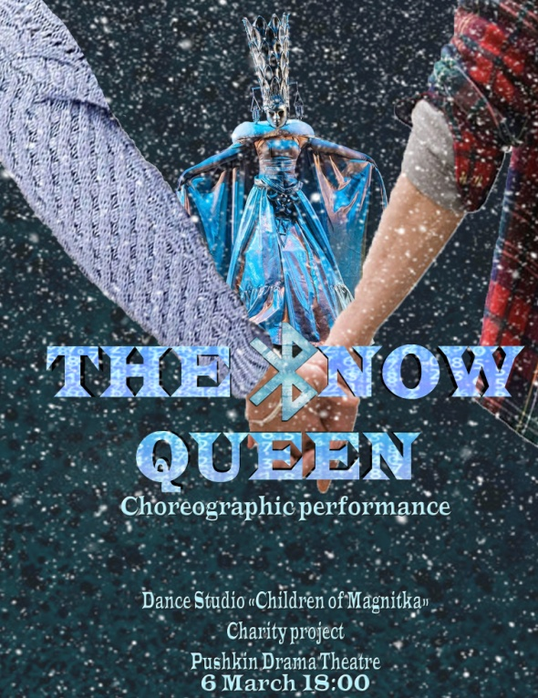 | A | The story begins in a small provincial town where some people get together for some obvious reasons. They are Tikhon, Kabanikha, Boris, Kuligin, and Varvara, Tikhon’s sister. Katerina is married to a mama’s boy Tikhon. Kabanikha (the worst mother-in-law ever) has destroyed their relationship. As a result, Katerina has a love affair with Boris, a young man, whose uncle controls his inheritance... Her feeling of guilt and despair poisons her life and makes her put an end to it. So, she commits suicide to escape her miserable and unbearable life.
2 | 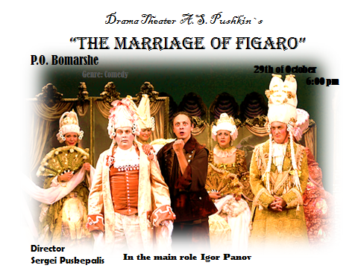 | B | It is set in Vienna during the reign of Joseph the second. It is about the most talented and genius composer of the 18th century – Wolfgang Amadeus Mozart through the eyes of the mediocre composer Antonio Salieri. There are rumours in the air that Salieri is a killer. He cannot accept the gift of God to such a person as Mozart. The play tells us how envy can lead into temptation and thoughtless behavior.
3 | 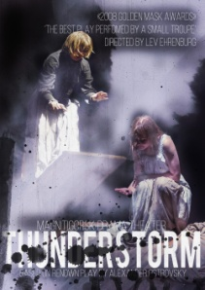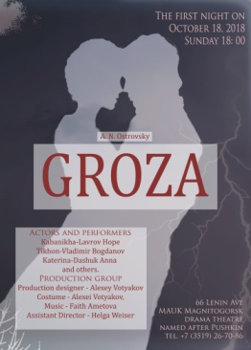 | C | It seems to me a very good decision to show the resistance of two heroines of the woman herself: the main character - the mother and the cat, who constantly interferes, demonstrating such female features as curiosity, tenderness, and cunning.
4 |  | D | Eugene Onegin, staged in our town is a well-known example of a lyric opera in 3 acts (7 scenes), composed by Pyotr Ilyich Tchaikovsky. Eugene Onegin is a study of how an intelligent but selfish man can ruin his life by rejecting the woman who could have been his soul mate and killing his best friend in a duel.
5 | 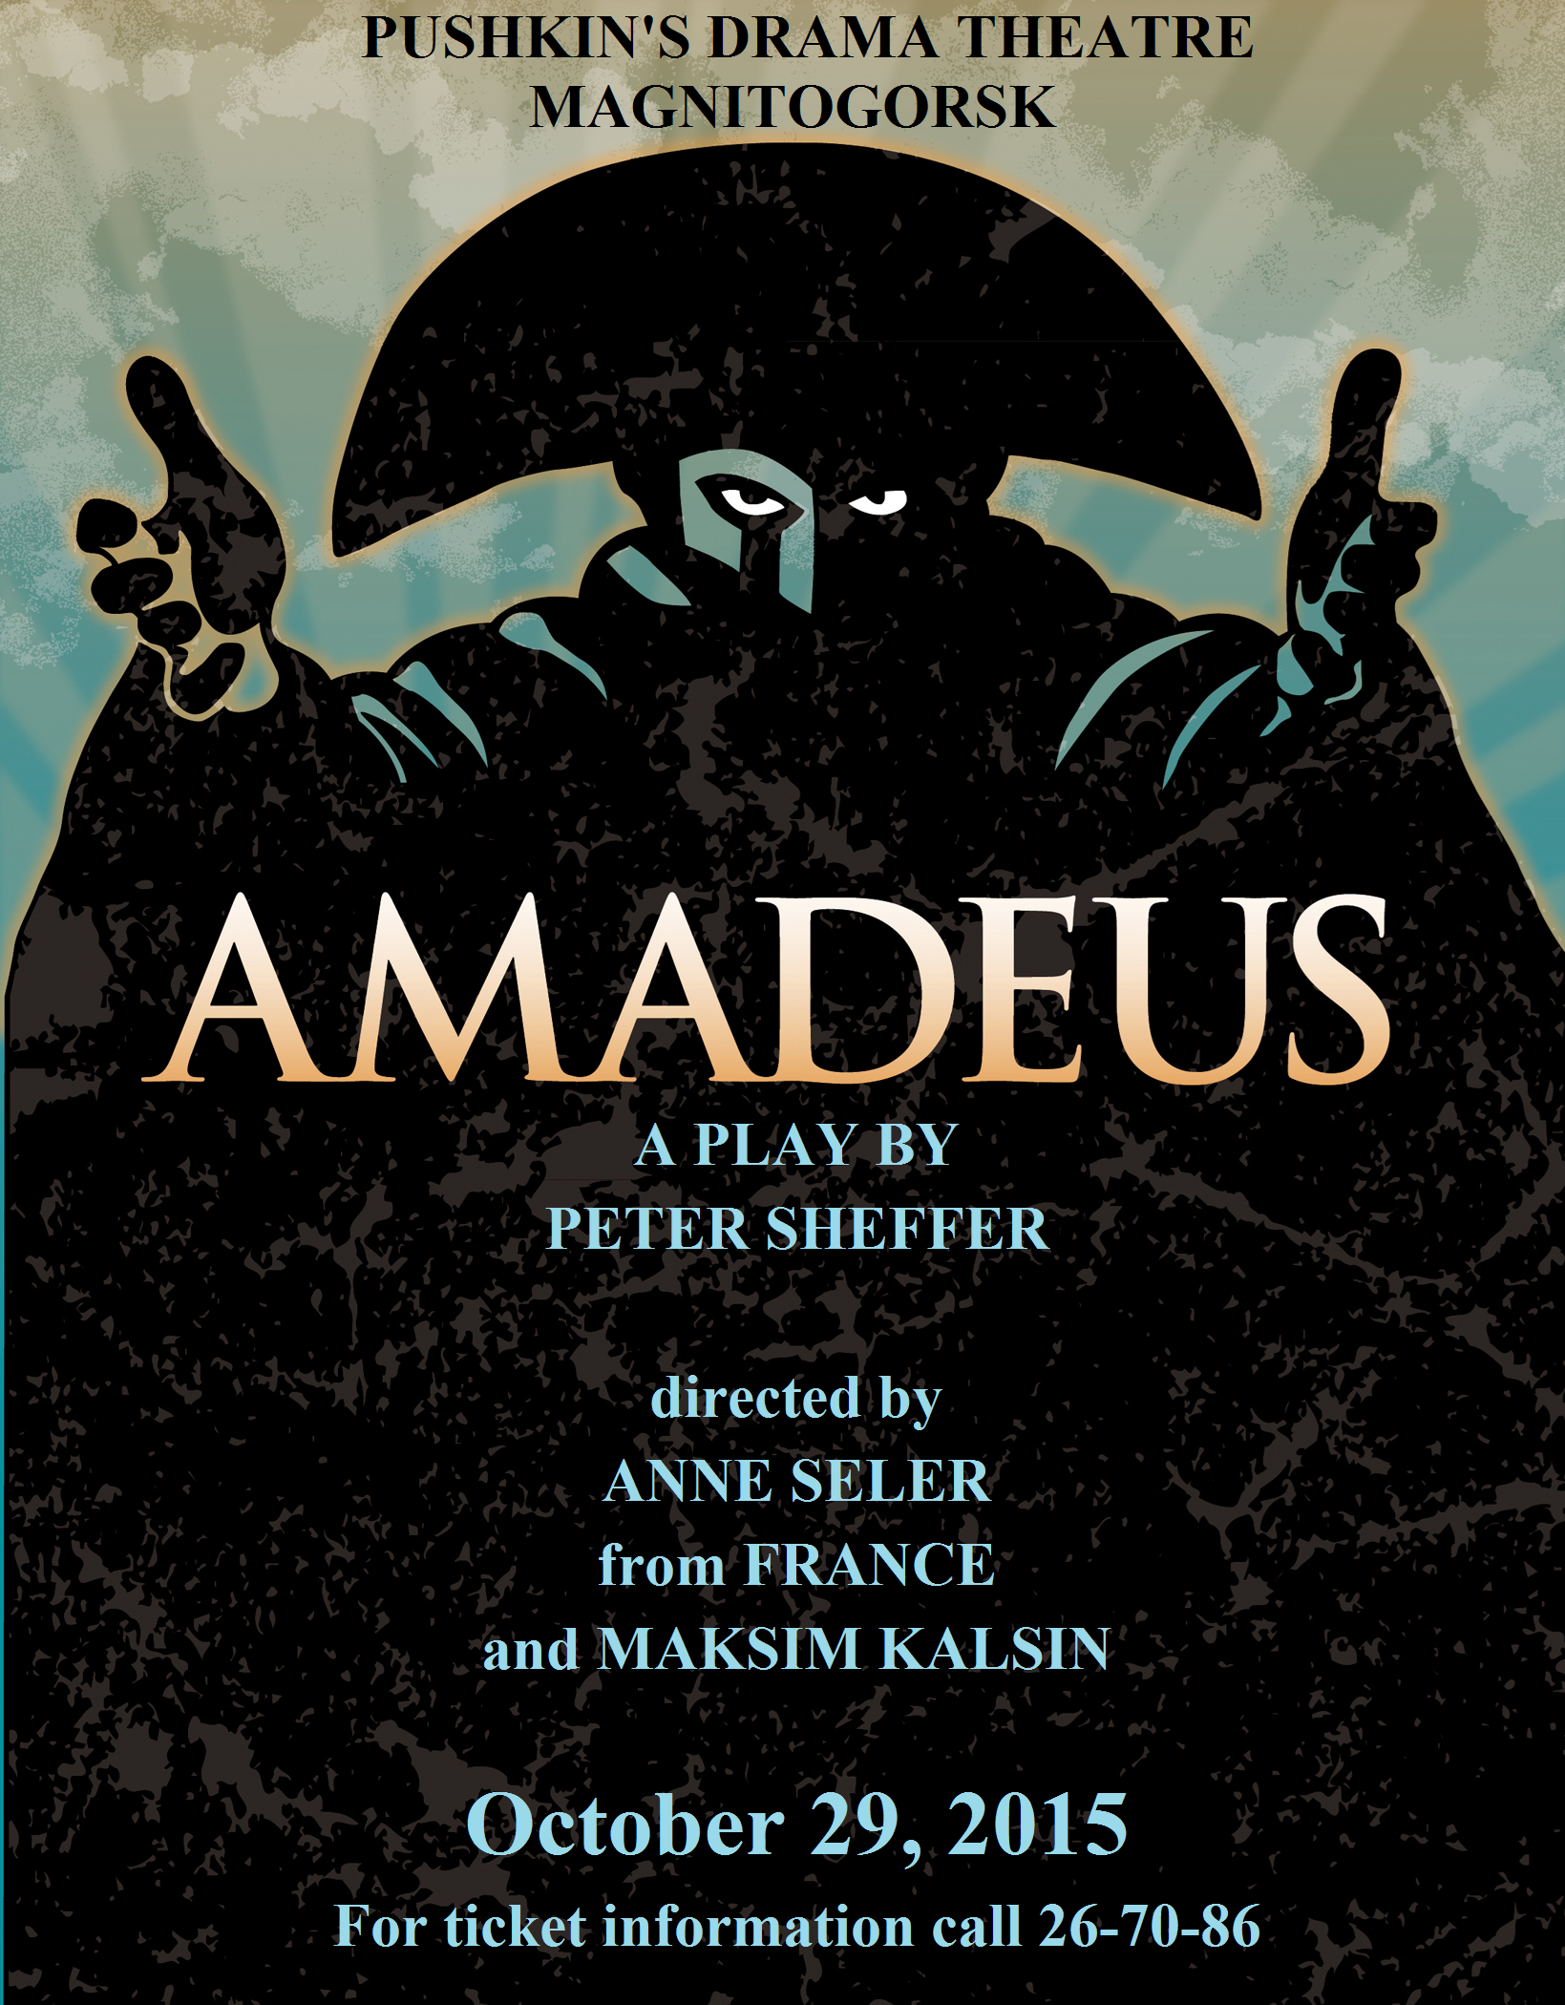 | E | The main characters are Gerda and her friend Kay. The modern interpretation shows us Kay becoming addicted to a computer game called “The Snow Queen”. The girl tries to help him, but she has to face up a great deal of difficulties and needs to overcome them. Despite that she never gets off the right track.
6 | 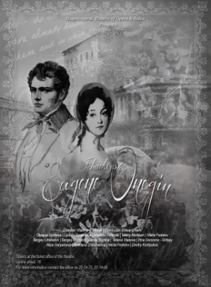 | F | Its plot seems to be light and uncomplicated. In the count Almaviva's castle the valets’ foreman Figaro and the Countess’s maid Suzanne are preparing for their wedding. The event causes many adventures. Despite the difficulties, Figaro will save his love and happiness.

Правила написания рецензии
Рецензия представляет собой описание, критический анализ и оценку произведения или фильма, а не пересказ. Не существует единой формы написания рецензии, т.к. во многом она зависит от видения и мнения автора, хотя, как и любая другая письменная работа, рецензия, несомненно, должна содержать:
1) введение
2) главную часть
3) заключение.
Рецензия должна содержать:
Введение, в котором вы должны определить главных героев и предмет повествования. Также во введении вы должны дать краткий план вашей основной части текста. Это поможет читателям сориентироваться, о чем будет текст и какие вопросы в нем будут затронуты.
- Выражения, которые можно использовать:
This well-written/informative/fascinating book…,
The film/story/play is set in…,
This original first novel…,
The film/book/play tells the story of…,
This work is based on…
The book/film/play I’m going to comment on is…
- Главная часть
Главная часть состоит из двух абзацев, где вы описываете основные события. Для более удобного чтения и структурирования аргументов используйте выражения firstly (во-первых), in the first part (в первой части), then (затем), secondly (во-вторых), lastly, finally (наконец), to conclude (в заключение).
- The main points of the plot:
The plot focuses on …,
The story begins…,
The plot has an unexpected twist …,
The film/play reaches a dramatic climax …,
The is practically eventless/ is full of events…,
The action takes place in…,
The main characters are…,
- General comments:
It is rather long/confusing/slow …,
The cast is excellent/weak …,
The script is dull/clever …,
It has a tragic/surprising end …,
It is beautifully written …,
… much better than…,
… not nearly as good as …,
It was disappointing compared to …,
It was surprisingly good …,
Although …,
Despite …,
The atmosphere and details of … are (exactly as in life)…,
It gives you food for thought…,
The story/film reflects life….
- Заключение
В Заключении автор должен представить свои рекомендации и свое мнение. В качестве оформления вывода вы можете использовать такие фразы:
What I have tried to show is… (Я попытался показать…) ,
So it can be seen that… (Итак, можно видеть, что…).
Выводы должны быть четкими и краткими. Для этого можно пользоваться следующими конструкциями:
- Recommendations:
Don’t miss it, it will change the way you see…,
It is well worth seeing/reading …,
I wouldn’t recommend it because …
Overall, I think …,
I would certainly recommend …,
All in all …,
I would strongly advise…,
Go and visit/see/buy…

Особенности написания
Например, если в устной речи используется выражение I don’t, то в письменной оно должно употребляться в форме I do not.

REVIEW. EXAMPLE.

Review to the play “Groza”
The performance I am going to comment on is “Groza”. This original play, directed by Lev Ehrenburg, is a modern version of the fascinating play by Nikolai Ostrovsky. This version was awarded the Golden Mask in 2007. It tells the audience the story of broken dreams, unfulfilled hopes, misunderstanding based on stupidity and indifference, which brought the heroine to the dramatic end.
The story begins in a small provincial town where some people get together for some obvious reasons. They are Tikhon, Kabanikha, Boris, Kuligin, and Varvara. They are not satisfied with their life but they cannot do anything to change it for the better. Up to this moment, the plot is practically eventless and then it makes an unexpected twist! A chain of events happened and made everything even worse. Tikhon left the town on business. Katerina, surrounded by people who do not care about her and her feelings, has a love affair with Boris but that does not bring her happiness and she commits suicide.
Ehrenburg showed strong feelings of anger and tenderness. The excellent cast helps him: the professional acting by Nadezhda Lavrova, Vladimir Bogdanov, Anna Dashuk and other actors attracts the audience to the performance. The dark scenery, unusual costumes and music help to reflect the atmosphere of the place and the feelings of the characters.
Ehrenburg’s “Groza” gives you food for thought. You may dislike it but it will not leave you indifferent. I would still recommend you to see it because the message of the play is very inspiring.

Task № 1
Read the play review on the drama “Thunderstorm”.

“Thunderstorm” is a famous literary work written by N. Ostrovsky. It is considered to be among the best-loved classics in Russian literature and has been staged for a number of times since 1859 when it was first played. The troupe of Magnitogorsk Pushkin Drama Theatre showed the premiere of “Thunderstorm” on 16th February, 2007. It was directed by Lev Ehrenburg and was a success having won the Russian National Theatrical Award “Gold Mask” in 2008.
The action of “Thunderstorm” unfolds in a fictional, provincial town of Kalinov in the XIX century. The main character, Katerina, being married, falls in love with Boris. The lovers arrange secret dates, but Katerina can’t live in lie, so she confesses of her betrayal to her husband Tikhon. Kabanikha, Tikhon’s mother, overhears her confession and Katerina’s life becomes unbearable. The play ends tragically. When Boris leaves Katerina alone with all her problems, having escaped from the town, she rushes from the cliff into the river and dies.
In my opinion, Lev Ehrenburg managed to combine an amazing show and smooth scene changes, a clear focus and cohesiveness that are both impressive and extraordinary. Let me explain why. Firstly, the cast did an incredible job playing with skill and feeling second to none. Secondly, the profound music and stage design contributed much to the mood of the play and acting. Thirdly, the stage lights and costume design enhanced the impression of “Thunderstorm”.
In conclusion, I advise you to see it, as the play is moving, sometimes amusing, but most of all realistic and absorbing.

Task № 2
Read the review again and mark each statement with T if it is true, F if it is false or NS if it is not stated in the text. Find evidence in the review.

- “Thunderstorm” is an unknown drama.
- The first film based on this literary work was shot in 1859.
- Residents of Magnitogorsk have never seen the play.
- “Thunderstorm” has won a lot of theatrical awards.
- The main characters of the play are Katerina, Boris, Tikhon and Kabanikha.
- There is a happy end in the story.
- Lev Ehrenburg, the director, has done a smart job of the play.
- The actors and actresses played brilliantly.
- The success of the play was achieved only by the fascinating acting of the cast.
- The author of the review doesn’t recommend to watch the drama.

Task № 3
“Amadeus” by Petter Sheffer
Glory, envy and murder. You can find all these and more in this excellent play. It is not only about love for the art of music, but it is also about much more.
“Amadeus” is set in Vienna during the reign of Joseph the second. It is about the most talented and genius composer of the 18th century – Wolfgang Amadeus Mozart through the eyes of the mediocre composer Antonio Salieri. There are rumours in the air that Salieri is a killer. He cannot accept the gift of God to such a person as Mozart. The play tells us how envy can lead into temptation and thoughtless behavior.
Why did I enjoy this play? Well, the plot was very exciting and interesting. What is more, the performance was a pleasant surprise for me. The believable game and vocals of the actors moved the audience back to that era.
Also, the beautiful decorations and costumes had recreated the spirit of that time. I should say that the music was performed by the orchestra and played an important role. The play showed me how composers lived and the darker side of glory and talent.
All in all, if you like drama and tragedy or if you are interested in history or you just love listening to classical music, I can highly recommend “Amadeus”. It left an incredible impression on us. We’d hope that we could share our emotions with you. That’s all we wanted to say about this play.

Say if the statements are True, False or Not Stated:
- “Amadeus” is set in Paris during the reign of Joseph the second.
- It is about the most talented and genius writer of the 18th century.
- Wolfgang Amadeus Mozart was born in Vienna.
- There are rumours in the air that Salieri is a killer.
- Salieri has a large family.
- The performance was rather boring.
- The plot was exciting and interesting.
- The scenery was beautiful.
- Music didn’t play an important role in the performance.
- The pay “Amadeus” is a comedy.

Task № 4

Good afternoon, Ladies and Gentlemen! My name is Arthur and I’m a specialist on advertising from Magnitogorsk Pushkin drama theatre. We are pleased to inform you that a new performance “Groza”, the Laureate [lo:riət] of the National theatre award “The Golden Mask”, will be soon presented on the stage of your theater. “Groza” is staged by a talented director Lev Ehrenburg who tries to get away from the standards of the classical play. He showed the problems of people of a small provincial town as he is interested in the “living life” but he did it in an unusual, even shocking way. His vision is quite different from what you can expect.
Here, all the characters are victims of circumstances, all of them suffer. They are not satisfied with their lives but they cannot do anything to change them for the better. Katerina is married to a mama’s boy Tikhon. Kabanikha (the worst mother-in-law ever) has destroyed their relationship. As a result, Katerina has a love affair with Boris, a young man, whose uncle controls his inheritance... Her feelings of guilt and despair poison her life and make her put an end to it. So, she commits suicide to escape her miserable and unbearable life.
This performance contains a lot of life, expression and acting. The play evokes strong emotions: either irritation and anger, or passion and tenderness, almost Christian virtue. Ehrenburg staged a very Russian performance because of the mysterious Russian soul.
The excellent cast helps him: the professional acting by Nadezhda Lavrova, Vladimir Bogdanov, Evgeniy Brazhenkov, Anna Dashuk and other actors. The dark scenery and unusual costumes help to reflect the atmosphere of the place. There are no special effects or soundtracks .The music just helps to express the feelings of the characters.
Ehrenburg’s “Groza” gives you food for thought. You may dislike it but it will not leave you indifferent. I strongly recommend you to see it because the message of the play is very inspiring. You can do it on the 18th of October, on Sunday at 6 p.m. Those who are looking for best viewing seats can go to the Stalls section which is nearest to the stage. Central seats in the middle of the Stalls are ideal, too. We offer discounted tickets for disabled people, groups of students and organisations.
You can find us at 66 Lenin avenue. You can get there easily by bus, by tram or by taxi. You can book seats beforehand. There are some age restrictions. It is recommended to young people of 18 and older.
Don’t miss it!
1.Give the Russian equivalents for:
a specialist on advertising | the play evokes strong emotions
the National theatre award | the mysterious Russian soul
staged by a talented director | the excellent cast
to get away from the standards of the classical play | to reflect the atmosphere of the place
in an unusual, even shocking way | no special effects or soundtracks
to change it for the better | the music helps to express the feelings of the characters
her feelings of guilt and despair poison her life | food for thought
to escape from her miserable and unbearable life | it will not leave you indifferent
I strongly recommend you to see it | the best viewing seats
we offer discounted tickets for disabled people | book seats beforehand
age restrictions | it is recommended to

2.Ask 10 special questions to the text (who, when, why, what, how, etc.). Remember the grammar rules.

3. Finish the sentences, using the text.
1. I’m a specialist on …
2. We are pleased to inform you that ….
3. “Groza” is staged by …
4. He showed the problems of people of a small provincial town …
5. This performance contains a lot of life,….
6. The play evokes strong emotions…
7. The dark scenery and unusual costumes …
8.There are no special….
9.Ehrenburg’s “Groza” gives….
10.You can do it …
11.For those who are looking for best viewing …
12.We offer discounted tickets for …
13.You can book….
14 There are some….
15. It is recommended to … .

TASK2

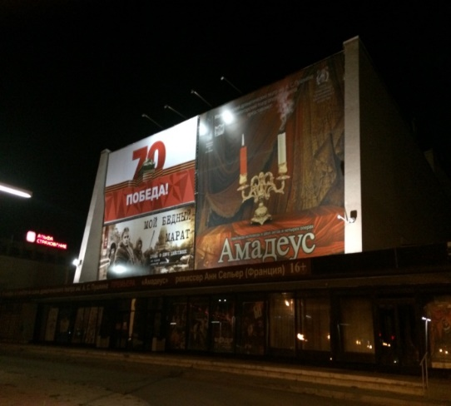 | Study the advertisement.  You have decided to go to Magnitogorsk Drama Theatre with your classmates and now you are calling to find out more about it. In 1.5 minutes you are to ask five questions to find out the following:  1. date for the premiere  2. ticket price  3. availability of group price reduction  4. how to get to Magnitogorsk Drama Theatre  5. time of the latest show

Study the advertisement.  You have decided to go to Magnitogorsk Opera and Ballet Theatre with your friends and now you are calling to find out more about it. In 1.5 minutes you are to ask five questions to find out the following:  1. whether tickets in the stalls are available  2. cost of the tickets in the stalls and in the balcony  3. availability of discounts if ordered online  4. if a program is provided  5. beginning of the performance | 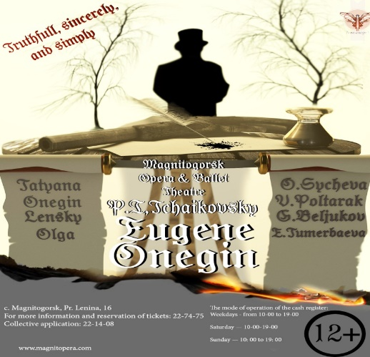

Crossword №1 [7]
Fill in the crossword and find out the name of the second largest city in Chelyabinsk region that has a rich cultural life.
1.
2.
3.
4.
5.
6.
7.
8.
9.
10.
11.
12.

- The Russian National Theatrical Award given to Magnitogorsk Pushkin Drama Theatre in 2008 for the drama “Thunderstorm”.
- The act of performing a play, dance or other form of entertainment.
- The part of a theatre where actors or musicians perform.
- The surname of one of the main characters of the book by Pushkin and the stage version of the opera in 3 acts that you can see in Magnitogorsk Theatre of Opera and Ballet.
- Electric lamps that show the actors in a theatre.
- A small model of a person or animal that you can move by pulling wires or strings, or by putting your hand inside it. In Magnitogorsk young children can watch performances with such models: “A kitten named Woof”, “Hen Ryaba” and some others.
- A place in a theatre where you can buy tickets for a play, performance, etc.
- Very exciting and interesting.
- Special clothes actors wear in a play.
- A person in a play or story.
Big pieces of cloth that hide the stage before the play starts.
- Powder, cream, etc. that actors put on their faces before a play.

Crossword №2 Write the words into the crossword.

1
2
3
B
4

- The part of a theatre where actors, dancers, etc stand and move.
- A short time between two parts of a play or concert.
- A person who acts in plays, films or television programmes.
- All the people who are watching or listening to a film, play, concert or the television.

Список использованной литературы
Ссылки на интернет-сайты

- https://yandex.ru/images/search?text=лексика%20по%20теме%20театр%20на%20английском%20языке&stype=image&lr=235&source=wiz&pos=0&img_url=https%3A%2F%2Fcdn-nus-1.pinme.ru%2Ftumb%2F600%2Fphoto%2F00%2F8a%2F008adecbc3bd5ea5924d08c0e3cf4542.jpg&rpt=simage
- http://lingvotutor.ru/theater-en-ru
- Боярская Ю.А..Тесты по английскому языку для подготовки к экзаменам:Учеб.пособие/Е.С.Музланова,Е.И.Кисунько.-М.:ООО «ИздательствоАстрель»,2004.-254
- https://yandex.ru/images/search?pos=1&img_url=http%3A%2F%2Fwww.verstov.info%2Fuploads%2Fposts%2F2016-06%2F1467268981_2212.jpg&text=фото%20спектаклей%20магнитогорска&lr=235&rpt=simage&source=wiz
- https://www.langnotes.ru/english/vocabularies/theatre
- https://multiurok.ru/files/zadanie-v-formate-oge-v-ramkakh-proektov-po-teme-r.html
- Macmillan English Dictionary for Advanced Learners, International Student Edition,2006
- https://yandex.ru/images/search?pos=1&img_url=http%3A%2F%2Fwww.verstov.info%2Fuploads%2Fposts%2F2016-06%2F1467268981_2212.jpg&text=фото%20спектаклей%20магнитогорска&lr=235&rpt=simage&source=wiz

