Short term plan
Lesson plan
Theme: Classroom routines
LESSON: 5 |  |  |  |  | School:
Date: |  |  |  |  | Teacher name: Khilola Khodjaeva
CLASS: 1 |  |  |  |  | Number present: 15 |  |  | absent: 0
Learning objectives(s) that this lesson is contributing to |  |  | 1UE8, 1S3, 1L1,1L3, 1UE3
Lesson objectives |  |  | All learners will be able to:
Use basic words according to the theme “Colors” and “Numbers” to say how many and what color something someone has .
Pronounce new words( stand up, sit down, read, write, open, close, listen to)and express intelligibly.
Most learners will be able to:
Recognize the spoken form of a limited range of basic and everyday classroom words.
Follow the short instructions for basic classroom routines.
Some learners will be able to:
Use imperative forms of common verbs related to classroom routines.
Previous learning |  |  | Reviewing numbers 1-10 and colors
Plan
Planned timings | Planned activities |  |  |  |  |  | Resources
Start  3min. | (W) Warm up.  Watching a video «Numbers Song-children songs» |  |  |  |  |  | www.learningchocolate.com
Middle  5min.  3min.  8min.  5min.  5min.  3min.  End  3min. | (P) Learners in two lines facing their partner. One learner has to set of flashcards above and says what, how many and what color something he has. Learners then change role.  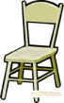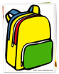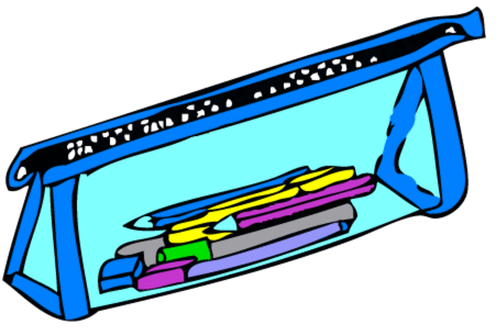  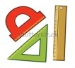  (W)Energizer “One house, two houses”.  Teacher gives instructions: Teacher says “One house,  learners match 2 hands. Teacher says “Three houses, three learners match hands.  The presentation of new words. Listen and say. Teacher introduces words (stand up, sit down, read, write, open, close, listen to ) with mime. Teacher drills the pronunciation with whole class and with individual learners. Students answer the questions “What does he/she do? Does he/she reads/ write/ listen to music?.. ”  (P). One learner shows the activity with new words and other learner names this activity.  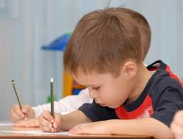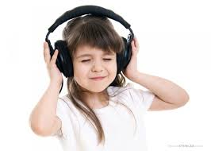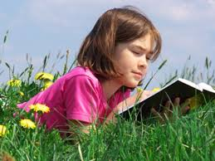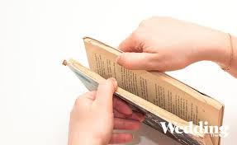  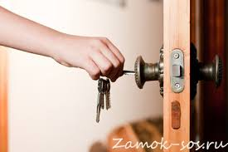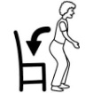  (W)Game for revising the topic” Colors” and consolidating the topic “Classroom routines “. The teacher distributes colored cards and says: “The Yellows stand up.” Students with yellow cards should stand up . The teacher says “The Greens open the books.” Students with green cards should open the books…  (G). Students match the pictures and words stand up, sit down, read, write, open, close, listen to.  (W) Students complete “can-do” cards  I can V or X  Count 1-10  Names the color  Read words  Write words  Open the door |  |  |  |  |  | Flashcards with classroom objects pictures  Pictures with activity words:  stand up, sit down, read, write, open, close, listen to  Pictures with activities  colored cards  Pictures and word cards  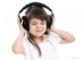  close listen to sit down Write read open  “can-do” cards  I can V or X  Count 1-10  Names the color  Read words  Write words  Open the door
Additional information
Differentiation – how do you plan to give more support? How do you plan to challenge the more able learners? |  |  |  | Assessment – how are you planning to check learners’ learning? |  | Cross-curricular links  Health and safety check  ICT links  Values links
More support:  Teacher activates weak learners through the use of suppotive questions that challenge learners’ thinking processes, through the use collaborative talk to help learners understand their own thoughts and the thoughts of others. Teacher and learners use positive language and body language.  More-able learners:  Teacher provides space for reflection on what they can now do and still have to achieve |  |  |  | Learners develop their self-assessment skills in pair and group work. Teacher provides feedback.
Reflection  Were the lesson objectives/learning objectives realistic?  What did the learners learn today?  What was the learning atmosphere like?  Did my planned differentiation work well?  Did I stick to timings? What changes did I make from my plan and why? |  | Use the space below to reflect on your lesson. Answer the most relevant questions from the box on the left about your lesson.
Summary evaluation

What two things went really well (consider both teaching and learning)?

1:

2:
What two things would have improved the lesson (consider both teaching and learning)?

1:

2:

What have I learned from this lesson about the class or individuals that will inform my next lesson?

