Short term lesson plan
Unit of a long term plan  Unit 6. Tradition and language |  |  | School:
Date: |  |  | Teacher’s name: Zhumanayeva Bayansulu
Class: 9 |  |  | Number present: |  | Number absent:
Lesson title |  |  | Extreme adjectives.
Learning objectives(s) that this lesson is contributing to |  | 9.C9 use imagination to express thoughts, ideas, experiences and feelings  9.C10 use talk or writing as a means of reflecting on and exploring a range of perspectives on the world  9.L1 understand the main points in unsupported extended talk on a wide range of general and curricular topics, including talk on a limited range of unfamiliar topics  9.L2 understand specific information in unsupported extended talk on a wide range of general and curricular topics, including talk on a limited range of unfamiliar topics
Lesson objectives |  | All learners will be able to:  - Identify the theme, new words and use them as the basis for discussion.  - Demonstrate knowledge for usage of the extreme adjectives.Transfer information from the given information into a graphic organizer.  Most learners will be able to:  - Select, compile, and synthesize information for an oral presentation  - Provide a point of view in conversations and discussions; speak about experiences.  - Some learners will be able to:  - Respond to and discuss the reading passage using interpretive, evaluative and creative thinking skills.  - Make a presentation about the experiences using extreme adjectives.Respond to and discuss the reading passage using interpretive, evaluative and creative thinking skills.
Value links |  | Cooperation, respect each other's opinion, support, functional literacy.
Crosscurricular links |  | Social Science, Information Technology, Geography, Biology, P.E., sport.
Previous learning |  | Talking about the experiences.
Useof ICT |  | Smart board for showing a presentation, getting additional information, playing the audio files.
Intercultural awareness |  | Students will be able to understand that people should speak about their experiences and give some advice.
Health and Safety |  | Breaks and physical activities used.  Everyday classroom precautions will ensure that safety measures are provided to prevent the exposure of electrical power cords.
Plan
Planned timings | Planned activities |  |  | Resources
Beginning of the lesson  8 min. | The lesson greeting.  The teacher sets the lesson objectives, letting students know what to anticipate from the lesson.  Warm up. Free talk.  Focus on the photos of great dates and elicit what the people are doing. What adjectives can you use to describe these things.(exciting, awful, stunning). |  |  | Slide (useful phrases)  Pictures  PPT  Student Book p.72  Writing  Worksheet
Main  Activities  13 min.  13 min. | LISTENING TASK:  Vocabulary exercises. Ex.1 - 2 p.72  The teacher asks Sts. To give the meaning of extreme adjectives.  Vocabulary work:  Extreme adjective Meaning  stunning  filthy  terrifying  Ex.3 p.72. I have never done this because it’s…..  Circle two adjectives to make a pair and describe great dates:  1. awful/ interesting/ hilarious/ bad  2. gorgeous/ furious/ angry/ memorable  3. exhausting/ unpleasant/ terrifying/ tiring  4. frightening/ terrifying/ hilarious/ unpleasant  5. funny/ interesting/ fascinating/ memorable  6. gorgeous/ revolting/ unpleasant/ terrifying.  LISTENING TASK.  Ex. 4 -5 p.72.  Complete the table.  The class is divided into 7 groups and speaks about the experiences using extra adjectives.  Optional Activity: Vocabulary and Listening.  5 minute test, Test Bank MultiRom. |  |  | Student Book p.72  CD2.23  A table  Writing  Worksheet  Teacher’s Book p.156  Writing Worksheet  CD2.24  Student Book p.72  Teacher's Book p.94.
Ending the lesson  6 min. | Giving the home task. W.B. p.48  Students express their attitude to the lesson and give self-assessment using the method: “Six thinking hats”:  - Green: How can you use today's learning in different subjects?  - Red: How do you feel about your work today?  - White: What have you leant today?  - Black: What were the weaknesses of your work?  - Blue: How much progress have you made in this lesson? (Now I can, I still need to work on, I've improved in, today I learnt...)  Yellow: What did you like about today's lesson?  Slide (Homework)  Slide "Six thinking hats"  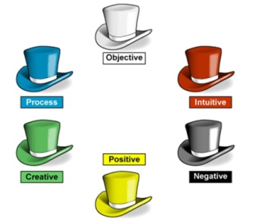
Differentiation –  how do you plan to give more support? How do you plan to challenge the more  able learners? |  |  | Assessment –  how are you planning to check learners’learning? |  |  | Critical thinking
Differentiation can be achieved through the selection of activities, identification of learning outcomes for a certain student, provision of individual support to learners, selection of learning materials and resources based on the individual abilities of learners. |  |  | Assessment criteria:  Identify the main idea in extended talks with little support.  Apply topic related vocabulary in speech appropriately arranging words and phrases into well-formed sentences.  Demonstrate the ability to participate in a conversation.  Descriptor:  A learner:  - selects an appropriate answer.  - completes the task.  - uses appropriate subject-specific vocabulary while speaking.  - discusses questions and answers the questions within the group.  - Observation  - Peer-assessment |  |  | Students think critically, exploring, developing, evaluating and making choices about their own and others’ ideas

Appendix1
Teacher observation checklist

Student's name ________________________________________

Positive Aspects
- Completed the individual role-card.
- Used extracts from the text to support his/her ideas.
- Asked open-ended questions.
- Listened while others talked.
- Encouraged peers to share their ideas.
- Added his/her own comments and ideas to other student's comments and ideas.
Negative Aspects
- Didn't complete the individual role-card.
- Didn't appear to be listening or interrupted when others were speaking.
- Did not use text to support his/her opinions.
Comments ___________________________________________________

Student Self-Assessment Checklist Student
Name: ________________________
Date: ______________________ Think about how well you are working in your group.
Place a check mark beside the skills you demonstrate in your role.
I listen attentively to others.
I express my thinking clearly and concisely.
I take turns. I encourage participation of all group members.
I show respect for alternative points of view.
I disagree agreeably.
I synthesize information from others.
I analyze ideas of others. I make connections to prior knowledge and experiences.

We can’t use ABSOLUTELY with normaladj. adjectives

EXTREME ADJECTIVES

We can’t use VERY, QUITE, A BIT with expr. adj.aaas
use
We use EXTREME ADJECTIVES to make a story more dramatic.They are stronger.
“We were exhausted” instead of “We were tired”.

We can make adjectives even stronger by adding an adverb (very, really, absolutely).“We were absolutelyexhausted” instead of “We were verytired”.

horrified exhausted tiny freezing brilliant delighted boiling filthy amazed/astonished furious fascinated starving hilarious petrified/terrified hideous
enormous/hugedevastated
normal
strong
tired ugly big shocked pleased dirty hot surprised small hungry upset angry interested cold clever frightened/scared funny
join!

complete with extreme adjectives

- His joke was absolutely _______________ (funny). We just couldn’t stop laughing!
- You should take a coat if you’re going out. It’s ________________(cold) out there tonight.
- Jane was really ________________(angry) when she discovered that her son had taken her car.
- We felt _________________(shocked) when we learnt about our neighbour’s accident.
- I haven’t eaten anything since lunchtime and I’m _____________ (hungry). Is that a sandwich?
- The hotel room was so _____________ (small) that we had to pile the suitcases up.
- Anne was _______________ (surprised) when her former boyfriend appeared out of the blue.
- My sister felt ________________ (upset) when her boyfriend went abroad for a year.
- The house was absolutely __________________(dirty) when we finished the renovation.

1. She’s very clever. She’s ____
2. It’s hot in here. It’s _________
3. This T-shirt is dirty. ________
4. I’m so tired! ______________
5. This place is very big! ______
6. You have a small hand _____
7. I’m interested in jazz music __
8. That dress is very ugly. _____
rewrite!
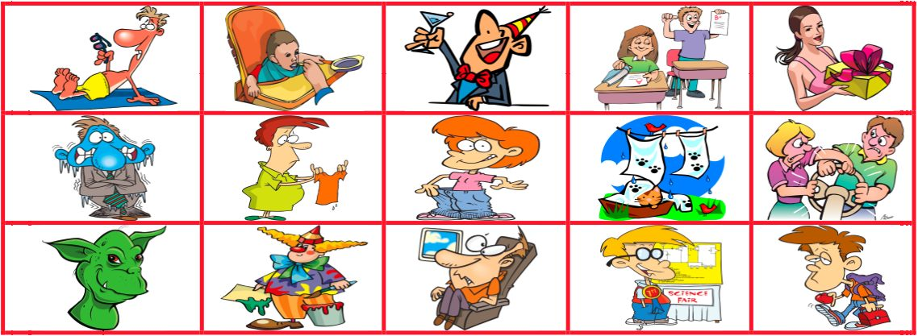

a) The monster in the film was absolutely ugly/hideous.  b) The clown’s performance was very funny/hilarious.  c) Tom was absolutely hot/boiling after going sunbathing.  d) Jeff was pleased/delighted with his surprise party.  e) Liz is a very clever/brilliant student.  f) Those jeans are too big/enormous for you.  g) The clothes were very dirty/filthy because of the dog. | h) John is absolutely scared/terrified of flying.  i) Mike feels a bit tired/exhausted in the mornings.  k) Jane was very surprised/astonished when we gave her such an expensive present.  l) Luck has always been interested/fascinated by science.  m) This T-shirt is slightly smaller/tiny now.  n) The weather is cold/freezing today! I need my coat!

