LESSON
Unit 6: Traditions and language
Date: |  |  | Teacher name: Altymyshova Aizada Aibekovna
Grade: 9 |  |  | Number present: |  | Number absent:
Theme of the lesson: |  | Why are some traditions and languages disappearing?
Learning objectives |  | 9.S3 give an opinion at sentence level on a limited range of general and curricular topics  9.R7 recognise typical features at word, sentence and text level in a limited range of written genres  9.S7 use appropriate subject-specific vocabulary and syntax to talk about a limited range of general topics
Lesson objectives |  | All learners will be able to:  Identify the theme, new words and use them as the basis for discussion.  Demonstrate knowledge for usage of the Present Simple for retelling a story about arranged marriage. Transfer information from the given information into a graphic organizer.  Most learners will be able to:  Select, compile, and synthesize information for an oral presentation  Provide a point of view in conversations and discussions; speak about arranged marriages using active vocabulary.  Some learners will be able to:  Respond to and discuss the reading passage using interpretive, evaluative and creative thinking skills.  Make a presentation about marriages in Kazakhstan. Respond to and discuss the reading passage using interpretive, evaluative and creative thinking skills.
Criteria |  | S-s can explain why they like Kazakh traditions
Previous lesson |  | Why are some traditions and languages disappearing?
Plan
Planned timings | Planned activities |  |  | Learners’ activities |  | Evaluation | Resources
Begining  5 min | GREETINGS  The teacher sets the lesson objectives, letting students know what to anticipate from the lesson.  Speak about arranged marriage  Warm up. Free talk.  On the board you can see the word: MARRIAGE  What do you imagine when you hear this word?  How will you choose your future husbands /wives?  ARRANGED MARRIAGE  What do you think about it?  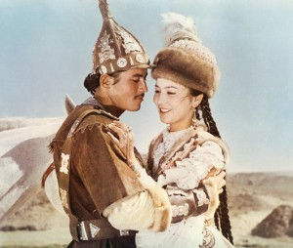 |  |  | Learners answer
Middle  30 min | LISTENING TASK:  Read and listen to the text and express your opinions:  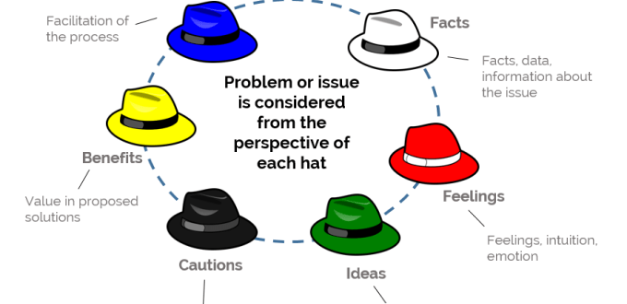  Discuss the text using the method of six hats:  1 group will speak about facts.  2 group - feelings.  3 group - creative ideas.  4 group -negative aspects.  5 group - benefit from the holidays in jungle.  6 group - conclusion.  True - false sentences.  Vocabulary work: find verbs with prepositions and make your sentences. Ex. 3 - 4 p.70.  Verb Preposition  Ex.5 p.70. Creative exercise  Optional activity: Reading.  Teacher's Book p.92. |  |  | Learners read and listen to the text and express your opinions  Learners choose true - false sentences, find verbs with prepositions and make your sentences |  | Mutual avaluation  Individual avaluation
End  5 min | Reflection  Teacher comes back to the learning objectives to reflect on students’ learning.  Self-assessment. How well do I understand?  4 - I can do this and explain it to someone else.  3 - I understand and can do this by myself.  2 - I need more practice.  1 - I don't understand this yet.  Hometask: W.B. p.50  Saying goodbye |  |  |  |  | Self-assessment

