This is how we play with a train!

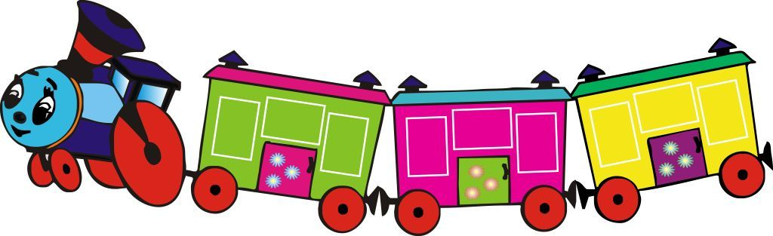
Main communicative aims: Revising and consolidating language from previous lessons
Language aims: To revise vocabulary for: colours (red, yellow, pink, green, purple, orange, blue), numbers (1 to 5), toys (train, an engine, cars), fruit (banana), commands: fly, roll, jump, go; To respond to the question What’s this? To consolidate understanding of the rhyme «The little train on a long, long track…», songs «The rainbow song» , «Five little ladybugs», «Banana Fruit Rhyme/Song»
Resources and preparation Pictures: a train, an engine, cars; video material (YouTube, Internet): «The rainbow song» (My Vox Songs Nursery Rhyme) , «Five little ladybugs» (Little Baby Bum), Fruit rhymes - Best Collection of Rhymes for Children in English «Banana Fruit Rhyme». You need three blocks and stickers: fruit (banana…), a rainbow and ladybugs, a toy banana.
Activity The teacher comes to class and says: Let’s play with a «Train» today. Look at my picture! What is it? (some pupils answer «It’s a train») . A teacher says: Yes! It’s a train. Good! А train has an engine and cars. Teacher points to the pictures and asks to repeat words «engine, cars». Also teacher gives the picture with an engine to the first child who answers correctly. (Igor), you are an engine, Lera, Misha, Alina… you are cars. Let’s make a train. (Teacher asks all the children to stand in the right order. Igor, (Engine) come to me, this is your place. Lera, please, stand behind Igor! One by one children come and stand in a train. Lera, please put your hands on Igor’s shoulders, Misha, put your hands on Lera’s shoulders, … I see a train, a little train; and this is your track ! (Teacher shows a way, where a little train goes (with a circle gesture)). We have three stations, three blocks: Fruit station, Rainbow and Ladybugs. (Teacher puts a sticker on each block according to the name of the stations). When you hear a whistle, start to go and chant the train rhyme together! «The little train on a long, long track, goes clickety, clickety, clickety-clack». The train stops at the station. On each station children can watch the video and play a game (name the colours, fruit, count the ladybugs, do the commands).
You can listen and sing the «The rainbow song» ( My Vox Songs Nursery Rhyme) , «Five little ladybugs» song Little Baby Bum… You can play a musical game «Funny Banana» (using Fruit rhymes-Best Collection of Rhymes for Children in English «Banana Fruit Rhyme»). Everyone sits in a circle and passes round a banana. When the music stops, whoever has the banana must do a forfeit, such as run round the circle and sit down again. At the end of this game, teacher says: Time to go! We are in the kindergarten! Boys and girls, thank you for your game!

