Ролевая игра «Мафия» на английском языке
В игре есть свои термины, которые вам нужно будет часто применять.
Вот небольшой словарь:
Мирные граждане - townspeople; the innocents; civilians; peaceful citizens.
Мафия - mafia; criminal; assassin.
Совершено преступление, убийство - crime; murder committed.
Подозревать - suspect.
Утверждать - allege; insist.
Обвинять - accuse; blame.
Быть виновным - to be guilty.
Быть невиновным - to be innocent.
Голосование - election; voting.
Казнить (предполагаемую мафию) -execute.
Наказать, заточить в тюрьму - punish; prison .
Жители – habitants.
Выиграть / проиграть -be won/lost.
В дневное время - in day time/by daylight.
Main characters:
mafia (3 persons)
doctor
detective/chief of police/ police officer
mayor
peaceful citizens

The night is coming. Everyone is sleeping.
But only mafia is getting up, they are meeting and choosing their victim. They are trying to kill the mayor of our little town. All criminals are tired; they have already chosen and maybe killed the victim that’s why they can go to bed. Mafia is sleeping.
Doctor is getting up. He can’t sleep, he feels something strange and dangerous happening in the town. He is opening his eyes and trying to treat and maybe reanimate somebody. He has done his work and with light heart he is going to bed.
The detective is getting up. He is opening his eyes and trying to find and to put mafia to prison.
The town is getting up. The nice morning is coming. Everyone is getting up excepting who was killed last night.
Our detective was trying to catch a criminal but he didn’t manage to do it. All his attempts were useless /useful.
The doctor of our town could save the life of one person. It means that nobody was killed and put to prison. Everyone is still alive.
And now I invite you to the town court. We together will try to find out who is mafia. Organize the voting.

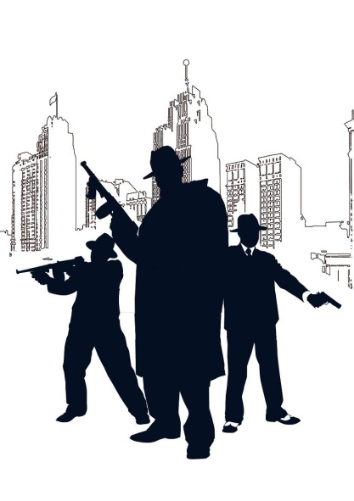  MAFIA | MAFIA | MAFIA
DOCTOR | 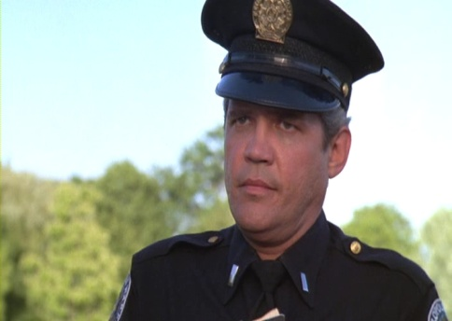  CHIEF  OF POLICE | DETECTIVE
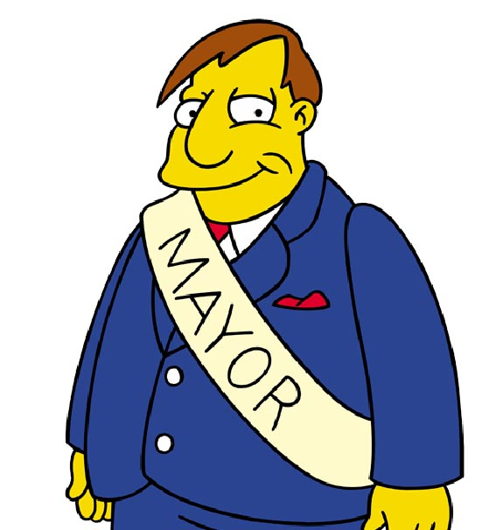  MAYOR | GARDENER  (Peaceful citizen) | GARDENER  (Peaceful citizen)

BAKER  (Peaceful citizen) | BAKER  (Peaceful citizen) | MECHANIC  (Peaceful citizen)
MECHANIC  (Peaceful citizen) | TEACHER  (Peaceful citizen) | TEACHER  (Peaceful citizen)
POSTMAN  (Peaceful citizen) | POSTMAN  (Peaceful citizen) | STUDENT  (Peaceful citizen)
STUDENT  (Peaceful citizen) | WAITER  (Peaceful citizen) | WAITER  (Peaceful citizen)
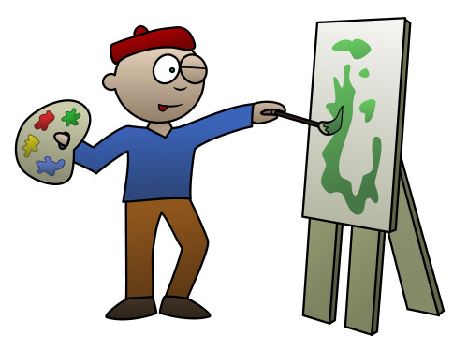  ARTIST  (Peaceful citizen) | FOOTBALLER  (Peaceful citizen) | ARTIST  (Peaceful citizen)
FOOTBALLER  (Peaceful citizen) | DOCTOR | 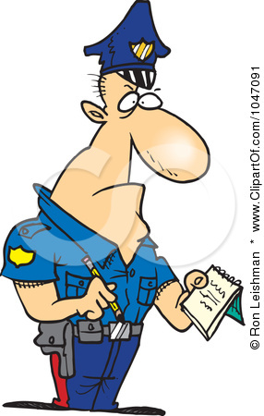  POLICE OFFICER

