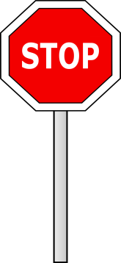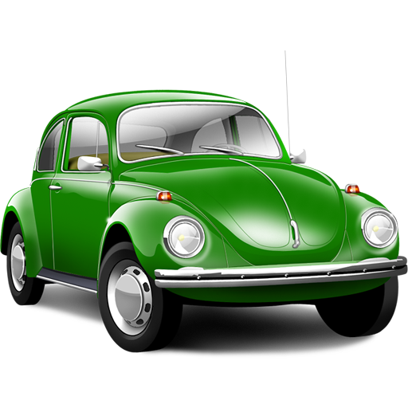

You’ve reached

your destination!

Terrible traffic jam!

Find a bypass.

Move three cells back.

Describe a car of your dream

You’ve beat traffic.

Throw dice again!

What kind of lights can be in a car?

Name three things in a car which are under the bonnet

Slippery road. Drive slowly.

Skip your move.

Name two features of a sedan or a hatchback

You’ve ran out of petrol, but somebody gave you a lift.

Throw dice

again!

What liquid can be used in a car?

You've ran a red light and police has stopped you.

Skip your move.

What can you keep in a boot of a car?

Name three “green” tips for drivers

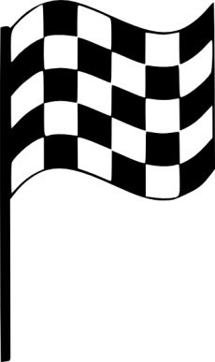

Name three different types of cars

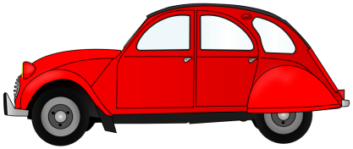

Name three road signs

Name three things in a car made of rubber

Green wave!

Move two cells forward.

What can be open and close in car?

Name two things

Name three German cars

Start