Казахстан, г. Алматы
Университет иностранных языков и деловой карьеры
Руководитель: к.п.н, профессор Шаяхметова Д.Б
Магистрант: Султанова М.Н
Intercultural communicative competence as a main aim foreign language teaching
The main goal of teaching becomes the ability “to communicate in a foreign language”. The content of teaching a foreign language is focused on the formation and development of all components of communicative competence: speaking skills and abilities, which are created on the basis of language, linguo-cultural knowledge and country studies.
In a number of works the concept “competency” is defined as intellectual and personal ability of an individual to practical activities, and “competence” as a contents component of the given ability in the form of knowledge, skills and aptitudes (Zimnyaya, 2003). The topic of intercultural competence became more and more important during the past years: globalization and worldwide contacts between companies, organizations and individuals need the ability to communicate in a successful way. Basic needs are sensitivity and self-consciousness: the understanding of other behaviors and ways of thinking as well as the ability to express one’s own point of view in a transparent way with the aim to be understood and respected by staying flexible where this is possible, and being clear and transparent where this is necessary.
Intercultural competence is the ability for successful communication with people of other cultures. This ability can be existing already at a young age, or be developed and improved thanks to willpower and competence. The bases for a successful intercultural communication are emotional competence, together with intercultural sensitivity. The goal of assessing intercultural competence is to find out if a person has this ability or the potential for it. Cultures can be different not only between continents or nations, but also within the same company or even family: every human being has its own history, its own life and therefore also (in a certain extent) its own culture resp. cultural affiliation (geographical, ethnical, moral, ethical, religious, political, historical). [1 pg160]
The concept of «communicative competence» was synthesized as a result of efforts of the methodologists around the world to define a common goal of teaching foreign languages, organize and synchronize the content and teaching methods to achieve this common goal. «Communicative competence» was first used as the term by Dell Hymes in his work «On communicative competence». This term has been formulated on the basis of N. Chomsky’s concept of «linguistic competence», which scholar used to determine the internal mental grammar of the individual, asserting that it is precisely here that language is represented in the form of abstract sets of rules, that are most clearly reflected in the subconscious intuitive representations of the individual on language. D.Hymes defined communicative competence as internal knowledge of situational appropriateness of language [2, 261]. An invaluable contribution to investigation and implementation of competency – based approach to teaching foreign languages in Kazakhstan was made by Salima Kunanbayeva, the rector of Kazakh Ablaikhan University of International Relations and World Languages. Her work is characterized by immensity, efficiency and in-depth content understanding of modern tasks. She is a leading expert on problems of the content and structure of foreign-language formation in Kazakhstan, the representative of education reforming programs, the coordinator of a number of European Union international programs.
Author of more than 100 scientific works. According to her investigation intercultural and communicative competences contain a key aspect as linguo-cultural orientation of functionally substantial vector of competences. Within the meaning of component structure “intercultural and communicative competences”, in terms of basic theoretical principles “cognitive-linguo-cultural methodology”, we consider it’s fair to point out "intercultural-communicative competence" as an independent competence. The structure of “intercultural and communicative competences” that we assumed is presented by the following sub-competences reflecting the training system, forming intercultural competence-based level of linguistic skills
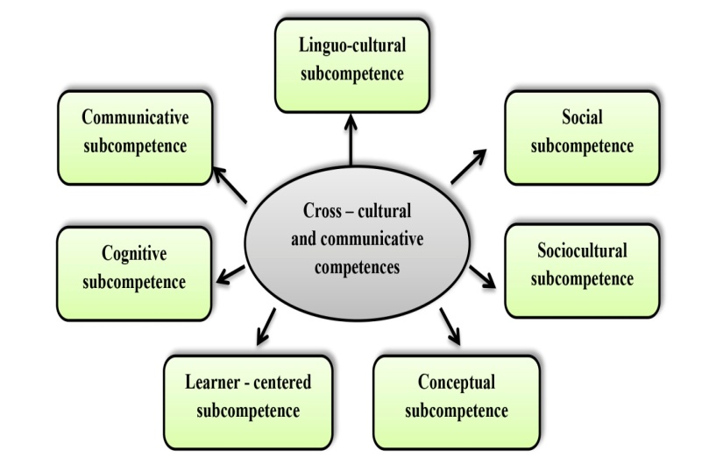
According to the conception of developing educational system of Kazakhstan on modern lines, such issues as communicative teaching of foreign languages, which are oriented to reach practical effects, are of paramount importance. All branches of professional state education standard involve a foreign subject, which aims to form and develop communicative competence of an expert. Future professional is a graduate, who extensively has a hand in vocational training in a foreign language which covers the spheres of science, technology, production and education. Mastering the communicative competence means for the student not just having a better command of language, but breaking of communicative barriers. The achievement of language competence helps to realize personal and business contacts in order to satisfy professional necessities, self – education and self – improvement. [2,pg.5]
Nowadays education in a broad sense has been distinguished as the investment in the development of the society. Orientation of the educational system of Kazakhstan to competence-based approach in the content of education is reflected in the field of foreign language teaching and in the formation of intercultural competence as an indicator of formation of a person's ability to participate effectively in a foreign language communication at a intercultural level. Due to the fact that a central element-level model as the subject of the educational process as well as the subject of intercultural communication is the learner, characteristics of the target and substantive aspects of a foreign language education are modelled in the context of intercultural paradigm. [11,pg.152] In the context of intercultural paradigm, the system of foreign language teaching is being modeled. It provides the development of intellectual (cognitive) aspects of the student's personality: in the process of comparing different conceptual systems, the worldview of a learner is enriched through intercultural reality and means of picture of world structuring. Culturally forming system of a foreign language education, modeled in the certain level of foreign language teaching, is based on the principles of time tested national education system and the basic principles of the world's education systems and the functioning of the forecast model under changing socioeconomic conditions. The principle of communicative and intercultural interaction provides the development of students' ability to intercultural dialogue in other languages.
Thus, at the forefront there comes not only mastering a foreign language as some amount of knowledge of lexical and grammatical units, but a personality capable of a foreign language communication in intercultural environment, i.e. capable of adequate interaction with other cultures. A linguistic personality should possess intercultural competence based on the totality of linguistic and psychological characteristics. In S.S.Kunanbayeva`s book The modernization of foreign language education: the linguocultural-communicative approach characterized by intercultural teaching. Teach through the country. It`s important because without unknown the country and the tradition of that country we cannot learn the language of that country. We should know their concepts, traditions, customs, style of life. ICC contains following sub competences.

the linguoculturological, | which forms a language student’s primary conceptualization of the world on the basis of their own culture. It is a linguacultural reflection of one's national language consciousness and mentality and it is the basis upon which an eventual ‘reconceptualization’ will occur during the transition to a MFL;
the social and socio-culturological, | which creates a language student's 'secondary cognitive consciousness' as a conception and form of the world of a different language society. It also forms in the student's cognitive system 'secondary constructions - knowledge' corresponding to their knowledge of the world and language of a different language society.  This sub-competency is developed as something 'new' on the basis of something 'given', that is, the secondary cognitive consciousness is formed upon the foundation of one's native culture and language;
the conceptual, | which provides the means for the study of MFL and is a reflection of the conceptually-organized' picture of the world' of a different society and the result of a common, integrated mechanism for working over natural language in an individual's consciousness.
the cognitive | provides the formation of language as an inalienable part of the process of knowledge-acquisition and thought.  The formation of the cognitive sub-competency manifests itself within the cognitive structure as mental constructs through which an individual comprehends the surrounding world and interacts with it as a speaker of natural language.  It also reflects a society's collective consciousness and mentality. During the transition to a new language, this sub-competency controls the conscious process of the acquisition of a 'secondary conceptualization of the world';
the personality-centered sub-competency | allows the use of general cognitive mechanisms in language and, more specifically, regulates the mechanism for the parallel working over of language within consciousness on three levels - the semantic, syntactical and pragmatic. In other words, the personality-centered sub-competency allows a reflection by the language student of a conception of the world through the anthropocentric paradigm;
the communicative sub-competency: | The modern tendency towards the growth of a global society, the understanding of language as the translator of a global human culture, the broadening of international integration and co-operation have caused the strengthening of the culture-forming and cognito-communicative functions of language.  Naturally, the transition to a new educational platform inspired by social change has, in the first instance, affected traditional basic methodological categories such as aims, content and learning outcomes.
The sub - competencies ] | identified within the structure of the intercultural communicative competency are formed according to the leading cognitive principle.  The characteristics of the integrated activity structure of the theory of intercultural-communicative teaching should be viewed as an integrative concept of the competency-based model of the ‘intermediator of intercultural communication’ which is reflected in and, provided by, the set of methodological principles of the cognito - linguaculturological methodology of MFL education. [1,pg345]

To foreign languages, revolutionary for problems of training, in this concept the fact that the device of formation of the text at the level of offers, namely the grammar and lexicon, were not considered more as the training purpose in itself, but were means for performance of the communicative purposes was.

Communicative approach was fundamental when developing content of levels of proficiency of FL for the developers of the project performing this work within the Project of the Council of Europe in the field of the modern languages. The developers also well understood that the offered structure of communicative competence is not exhaustive, and needs completion and specification. Thus, there was a new conceptual offer according to which the new model of content of education within communicative competence was developed.
The cultural barrier can become the real factor interfering mutual understanding of participants of communication and that to overcome it, training of pupils for real communication in a foreign language with carriers of this language is necessary. And here the paradox as long-term preparation for real intercultural communication consists in training communication in a foreign language with the peers belonging to the same culture is found. In it one of essential features of intercultural communication is seen in training in a foreign language at school. Namely, preparation for real intercultural communication, for real interaction of carriers of two cultures has the mediated character as process of training in a foreign language is carried out of the language environment, far from real functioning of target languages and culture.

References
- S.S. Kunanbayeva - The modernization of foreign language education: the linguocultural-communicative approach 2010
- D. H. Hymes. On communicative competence. In Pride, J.B.; Holmes, J. Sociolinguistics: selected readings. Harmondsworth: Penguin. pp. 269-293
- Sandra J. Savignon. Communicative Language Teaching: Linguistic Theory and Classroom Practice. – 22р.
- И.А. Зимняя – Ключевые компетенции - новая парадигма результат образования //Высшее образование сегодня. – 2003. - №5. – С. 34-42.
- Р.П. Мильруд., И.Р. Максимова – Современные концептуальные принципы коммуникативного обучения иностранным языкам //Иностранные языки в школе. – 2000. №4. –C.9-16.
- И.И. Халеева – О гендерных подходах к теории обучения языкам и культурам // Известия Российской академии образования. - 2000. - № 1. – С. 11-18.
- К. Кnарр – Intercultural Communication in EESE [Электронный ресурс]. Режим доступа: //http://www.cs.uu.nl/docs/vakken/bci/programma/intercull.html.
- Н.Н.Васильева – Межкультурная компетенция. Стратегии и техники её достижения. – Москва,41996. – 411с.
- Кулибаева Д.Н. Методологические основы управления образовательной системой школ международного типа. — Алматы: Изд. КАЗУМОиМЯ, 2006. — 480 с.
- Suleimeinova G.S. Teaching speaking skills at the English language lessons. Innovations in educational activities and the problems to improve the quality of education. - Almaty. 2012. – P. 152 - 154.
- Карабаева Л.Н. Педагогические условия формирования коммуникативной компетенции преподавателей иностранного языка в вузе: Автореф. дис. ... канд. пед. наук. — Туркестан, 2007. — 28 с

