Пәні: English Бекітемін:
Ұзақ мерзімді жоспарлау: Module 6.
Explorers and Inventions Мектеп директорының оқу ісі
бойынша орынбасары: Дюсупова Л.С.
LESSON: Module 6. Lesson:  Past Simple |  |  | School № 43school lyceum
Date |  |  | Teacher’s name: Z.A.Omarova
Class 3A |  |  | Present absent
Learning objectives(s) that this lesson is contributing to |  | 3.2.5.1- pronounce familiar words and short phrases intelligibly when reading aloud  3.1.6.1- understand some specific information and detail of short, supported information or talk on a limited range of general and some curricular topics  3.3.6.1- understand with considerable support, some specific information and detail in short, simple texts on a limited range of general and some curricular topics  3.4.2.1- write words and phrases of regular size and shape 3.5.7.1- use personal object pronouns [indirect] in conjunction with direct object nouns to describe actions and events  3.4.2.1- write words and phrases of regular size and shape 3.3.5.1- understand the main points of short simple texts on a limited range of familiar general and some curricular topics by using contextual clues  3.4.4.1- write with support short basic sentences with appropriate spaces between words  3.1.2.1- understand a limited range of short supported questions which ask for personal information  3.2.6.1- take turns when speaking with others in a limited range of short, basic
Aims |  | To practise storytelling. To talk about actions in the past.
Previous learning |  | Learners will need to be familiar with/reminded of subject, object and demonstrative pronouns, the use of adjectives in describing objects and feelings, and the formation of present simple questions.
Cross-curricular links |  | History
ICT skills |  | Using videos& pictures, working with URLs
Plan
Planned timings | Planned activities |  | Smiles Resources | Teacher Notes
Beginning the lesson  2 min  2 min  5 min  3.4.1.1 3.1.2.1 | Good afternoon, children. How are you today?  Look at me and smile.  Look to each other and smile.  Look behind and smile.  Stand up and go to the board. Dividing into the group. Sweet group. Take the sweets you like.  Today we are going to visit the town of the Past Simple. It's a very beautiful town. Who lives in this town? Look! These are funny gnomes. What are their names? Their names are Ted, Jack, Tim and Ben. They are nice, kind and friendly. They will show us the town. We shall learn some grammar rules, do exercises, sing songs and play games at the lesson.  (An activity to revise the vocabulary from the previous lesson.)  noughts and crosses  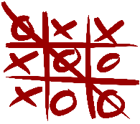  Description: to review the vocabulary from the previous lesson
PRESENTATION AND PRACTICE  5 min  3.2.5.1 3.1.6.1  2 min | Step 1 (Activities to present and activate the new language.) Listen, point and repeat. Then match.  Ex 4• Pupils’ books closed. The pupils repeat, chorally and/or individually.  • open your book. Play the CD. The pupils listen, point to the words and repeat the picture. Allow the pupils some time to complete the activity. Check their answers. |  | FLASH  CARDS  (41-47) (Track 01 CD2) Pupils book p 80 | Point to the flashcards at random, sometimes saying the right word and sometimes not. say yes or no
3.3.6.1 3.4.2.1  2 min | Step 2. Ex 5. Explain the activity. Read and complete. Then match. There is one extra sentence.  Description: to read the sentences and complete them. |  | Pupils book p 80
3.5.7.1  5 min | Step 3. Today we are going to visit the town Past Simple. Four gnomes live there. They will help us. STUDY SPOT (Activities to present and practice the past simple – regular verbs.) Read and complete. Ex 6 • Pupils’ books closed. Say, then write: I visited my friend yesterday.  Repeat, happened at a specific time. Explain that we add –ed at the end of the verb.  Slide 2  • Pupils’ books open. Go through the Study spot section briefly. |  | 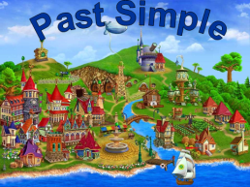  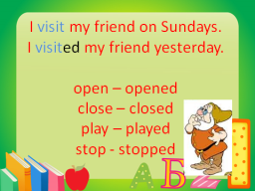  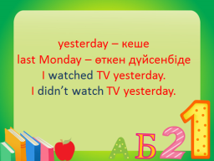 | Slides  1,2,3
3.4.2.1  2 min  3 min | Step 4 Look, read and correct. Ex 6 The pupils look at the pictures and correct the sentences.  Description: to read and complete.  Ex. 7. to correct the sentences.  Group work. Underline regular verbs.  Mary got up at 7 o'clock yesterday. She washed her face and cleaned her teeth. Then she had breakfast. She took her bag and went to school.  Jane came home at 2 o'clock yesterday. She had dinner. Then she cleaned her room. She did her homework. Then she played games.  My mother came home from work at 6 o'clock yesterday. She cooked supper. Then she watched TV. She read a book. She went to bed at 10 o'clock.  Description: to find regular verbs |  | Pupils book p 81  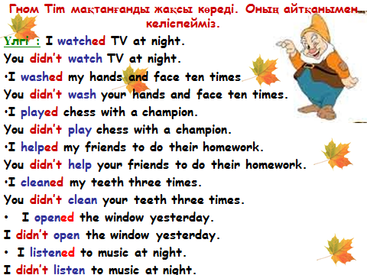  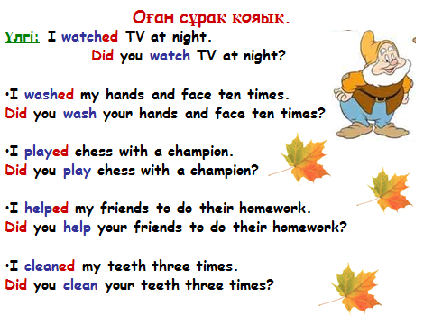 | Slides  5,6
Ending the lesson  3.2.6.1  3.4.1.1  3.1.2.1  3 min | (An activity to consolidate the language of the lesson.) Project: Yesterday, I … Tell the pupils to draw a sketch depicting an action they did yesterday and write a sentence about it. If you wish, you can assign some or all of the corresponding activities from the Activity Book for homework. |  | ACTIVITY BOOK (Optional)
2 min | Hometask

Underline regular verbs. Етістіктің астын сыз.
Mary got up at 7 o'clock yesterday. She washed her face and cleaned her teeth. Then she had breakfast. She took her bag and went to school.

Underline regular verbs. Етістіктің астын сыз.
Jane came home at 2 o'clock yesterday. She had dinner. She helped her mummy.Then she cleaned her room. She did her homework. Then she played games.

Underline regular verbs. Етістіктің астын сыз.
My mother came home from work at 6 o'clock yesterday. She cooked supper. Then she watched TV. She washed dishes. She read a book. She went to bed at 10 o'clock.

