ОЧУ СОШ “ЛИДЕР”
Учитель английского языка Гуро-Фролова Ольга Романовна
МОСКВА
2018-2019
29 03 2019
Guro-Frolova Olga
The theme: Step Idioms.
The aims: 1.Introduction with the new grammar material, to enrich students knowledge working on the new words and idioms to practice its pronunciation and teach them to use the idioms in their speech.
2. to develop students speaking and thinking abilities, to consolidate the material with asking and answering the guestions, to develop their memory on the learning English idioms.
3. to raise their interest to the English language, widing their scope, to bring up students striving of inquisitive on studing English language.
Eguipment: interactive board, electronic book, testcards.
The types of the lesson: combined
The method of the lesson: introduction, explaining, reading, speaking.
Procedure of the lesson.
I.Organization moment .(2m)
II. Phonetic drill: .(2 m )
III. Checking home task (5 m)
Read the text from the presentation.(1 m)
Take test cards and choose the correct answers.(5 m)
Change answers with your classmates check up and mark each other
dividing into departments
IV. Lexical material from the previous lesson (5 m)
V. Matching.Look at the board and choose from the test the words or the phrases that best correspond to the idioms
Look at the board read the definitions and write the correct idioms into each gap
Going for feedback (15 m)).
Read translate match and pronounce them.
VI. Staging.(5 m))
Act the dialogue paying attention to the underlined idioms
.
vii. Generalizing.(2m)
viii. Home task(2 m)
ix. Marking(1m)
Video A piece of cake
Доброе утро
Мы начинаем наш урок ,подводя итоги предыдущего модуля и переходя на следующий модуль ,который посвящен одной из самых интересных и необычных тем английского языка Взгляните на название следующего модуля и прочитайте его. A PIECE OF CAKE
Как вы думаете о чем пойдет речь в нашем уроке и чему он будет посвящен 7
IDIOMS
Наш сегодняшний урок будет посвящен идиомам
Как вы понимаете идиому?
Идиомы или фразеологизмы – это устойчивые обороты речи, неразложимые сочетания слов, понимаемые, как правило, в переносном значении
Идиома – это фраза, которая имеет переносное, образное значение. Данное значение нельзя вывести из отдельных слов, которые входят в состав этой фразы. Иногда идиомы могут выражать сразу буквальное значение, но чаще всего фигуральное, образное, переносное.

Например: A PIECE OF CAKE-.

Идиомы образуют важную часть словарного запаса как формального, так и неформального языка. Но в неформальном общении они используются чаще, например в фильмах и песнях идиомы встречаются очень часто.
Многие идиомы устаревают, выходят из использования. Поэтому стоит использовать проверенные словари идиом
Не стоит путать идиомы со сленгом. Идиомы не являются сленгом. Однако, следует помнить, что идиомы используют лишь в определенных ситуациях, то есть не всегда. Не стоит перенасыщать свою речь идиомами.
Использование идиом в определенном контексте в речи или на письме показывает высокий уровень владения иностранным языком.
Как выучить идиомы?
Для того, чтобы изучать идиомы было удобно, их можно сгруппировать по разным признакам или значениям – например, идиомы про еду .
Также стоит сказать, что иногда можно чётко подобрать похожую идиому из родного языка, с таким же значением и возможно даже похожую словами, входящими в состав идиоматической фразы, например подобрать что-то из русского, а иногда в русском или в любом другом вашем родном языке подобрать что-то похожее, чтобы перевести идиому крайне сложно.
Не старайтесь запомнить больше 10 идиом в день.
Идиомы на тему ЕДА
В Англии большинство магазинов имеют простые имена ,но есть особые магазины с не менее особыми названиями .Это было ваше домашнее задание и мы его сейчас проверим
Перед вами карточки с названиями магазинов и вы должны будете сказать какие идиомы могут быть использованы для каждого из этих разделов ..
1. Baker's – пекарня, где продают свежий продают хлеб и пирожные.
2. Fishmonger- рыбный отдел где вы можете купить морепродукты
3. Butcher's – мясной магазинчик
4. Dairy –где вы можете приобрести молоко, мороженое ,сыры ,творог
5 Greengrocer's – в таком магазине продают фрукты и овощи. Иногда можно найти и другие вещи, как яйца и молоко.
Какие отделы магазинов вы видите на экране
Перед вами лист с идиомами и их значениями и вам нужно будет найти идиомы которые будут соответствовать определенным магазинам или отделам магазина и подписать их .
Сегодня будут представлены 5 разделов и поэтому двое из учеников будут помогать тем кто вытащит тему
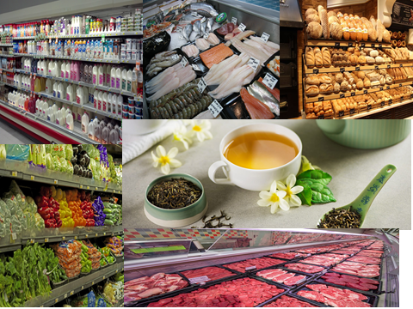
Good morning
We begin our lesson with a summary of the previous module and move on to the next module ,which is dedicated to one of the most interesting and unusual topics of the English language.
The title of the next module is . PIECE OF CAKE
What do you think about ?
How do you think what will be discussed in this tutorial and what it will focus on ?
IDIOMS
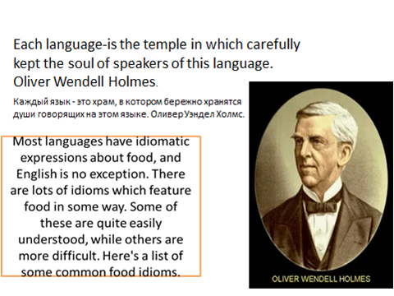
Our lesson today will be about idioms
How do you understand idioms?
Idioms or phraseological units are stable turns of speech, illegible combinations of words, understood, as a rule, in a figurative sense
An idiom is a phrase that has a figurative meaning. This meaning cannot be derived from the individual words that make up this phrase. Sometimes idioms can express literal meaning at once, but most often they are figurative
For example: a piece of cake.
Idioms are an important part of both the formal and informal language vocabulary. But in informal communication they are often used in movies and songs .
Many idioms become obsolete, go out of use. So you should use the tested dictionaries of idioms
Do not confuse idioms with slang. Idioms are not slang. However, it should be remembered that idioms are used only in certain situations, that is, not always. Don't oversaturate your speech with idioms.
The use of idioms in a particular context in speech or writing shows a high level of foreign language proficiency.
How to learn idioms?
In order to study idioms conveniently, they can be grouped according to different characteristics or values – for example, idioms about food .
It is also worth saying that sometimes you can clearly pick up a similar idiom from your native language, with the same meaning and perhaps even similar words that are part of an idiomatic phrase, for example, to pick up something from Russian, and sometimes in Russian or in any other of your native language to pick up something similar to translate the idiom is extremely difficult.
Don't try to remember more than 10 idioms a day
Idioms on the topic FOOD
In England, most stores have simple names, but there are special stores with no less special names .It was your homework and we will check it now
Before you cards with names of shops and you will have to tell what idioms can be used for each of these sections ..

1. Baker's is a bakery that sells fresh bread and cakes.
2. Fishmonger-fish Department where you can buy seafood
3. Butcher's-meat shop
4. Dairy-where you can buy milk, ice cream, cheese, cottage cheese
5 Greengrocer's-in this store sell fruits and vegetables. Sometimes you can find other things like eggs and milk.
What departments stores you see on the screen
Before you sheet with idioms and their values and you will need to find idioms that will correspond to certain shops or departments of the store and sign them .
Today will be presented with 5 sections and therefore two of the students will help those who will get the theme
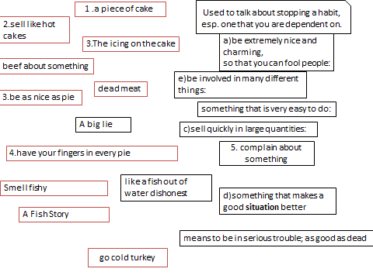
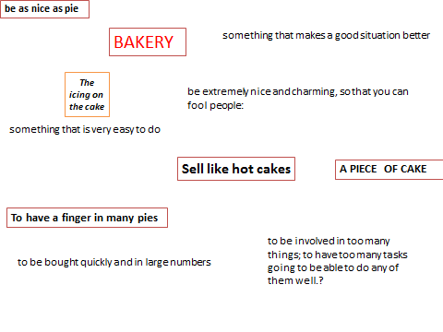

Baker's
be as nice as pie -be extremely nice and charming, so that you can fool people:
A PIECE OF CAKE-something that is very easy to do
Sell like hot cakes to be bought quickly and in large numbers
The icing on the cake-something that makes a good situation better the icing on the cake
something that makes a good situation even better:
I was just content to see my daughter in such a stable relationship but a grandchild, that really was the icing on the cake.
To have a finger in many pies-to be involved in too many things; to have too many tasks going to be able to do any of them well.?
MAKES YOUR MOUTH WATER слюнки текут
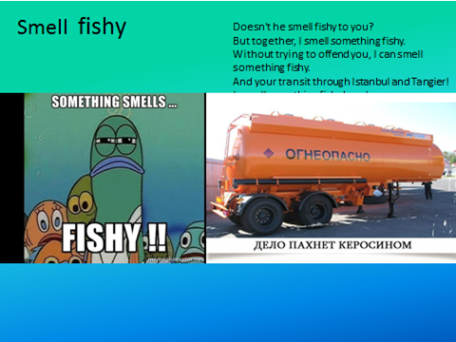
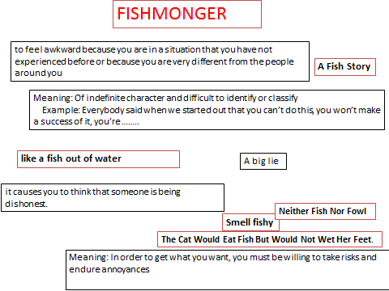

FISHMONGER
Smell fishy - it causes you to think that someone is being dishonest. smell fishy His excuses smell fishy to me.
informal
If a situation or an explanation smells fishy, it causes you to think that someone is being dishonest.
Тезаурус: синонимы и родственные слова
Not believable
like a fish out of water- to feel awkward because you are in a situation that you have not experienced before or because you are very different from the people around you-
Neither fish nor fowl Meaning of indefinite character and difficult to identify or classify
Everybody said when we started out that you can’t do this, you won’t make a success of it, you’re neither fish nor fowl.
The Cat Would Eat Fish But Would Not Wet Her Feet. Meaning: In order to get what you want, you must be willing to take risks and endure annoyances-
A Fish Story Meaning: A big lie Example: That’s just a fish story. Don’t try to fool me.- A Fish Story
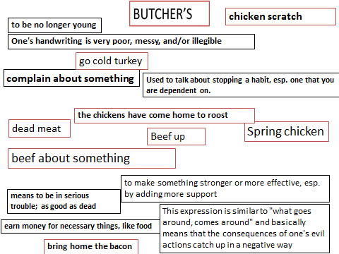

Butcher

to be no longer young-spring chicken
beef about something complain about something
beef up to make something stronger or more effective, esp. by adding more support-
-bring home the bacon earn money for necessary things, like food
the chickens have come home to roost
-This expression is similar to "what goes around, comes around" and basically means that the consequences of one's evil actions catch up in a negative way.
dead meat-means to be in serious trouble; as good as dead
go cold turkey Used to talk about stopping a habit, esp. one that you are dependent on.-
play chicken to play dangerous games in order to discover who is the bravest-
chicken scratch One's handwriting is very poor, messy, and/or illegible-
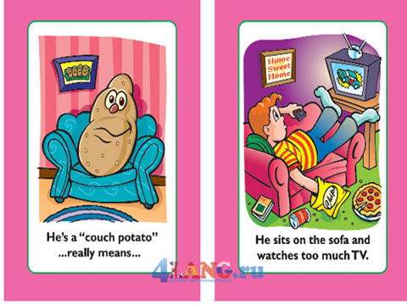

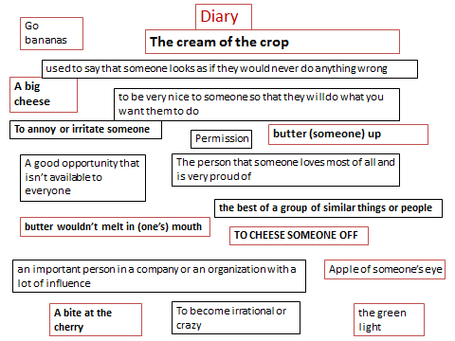

DAIRY
big cheese noun [ C ]
uk us informal
an important person in a company or an organization with a lot of influence:
He left business school and became a big cheese in the City.
IDIOM – TO CHEESE SOMEONE OFFMeaning – to annoy or irritate someone
In Context – He really cheesed me off when he said I don’t do my work correctly.
butter wouldn't melt in sb's mouth
used to say that someone looks as if they would never do anything wrong
выглядеть тихоней
butter sb up
informal — phrasal verb with butter uk /ˈbʌtər/ us verb [ T ]
to be very nice to someone so that they will do what you want them to do
льстить, умасливать
the cream of the crop
the best of a group of similar things or people:
The medical school's graduates are considered to be the cream of the crop and can get jobs wherever they want to.
milk of human kindness
the milk of human kindness
good, kind qualities
Greengrocer’s
the green light – permission
My boss gave me the green light to start the project
the apple doesn't fall far from the tree
also the apple never falls far from the tree
a child usually has a similar character or similar qualities to his or her parents:
Her daughter soon showed her own musical talent, proving that the apple doesn't fall far from the tree.
A bite at the cherry A good opportunity that isn’t available to everyone
Apple of someone’s eye
Meaning: The person that someone loves most of all and is very proud of
Example: His new baby girl was the apple of his eye.

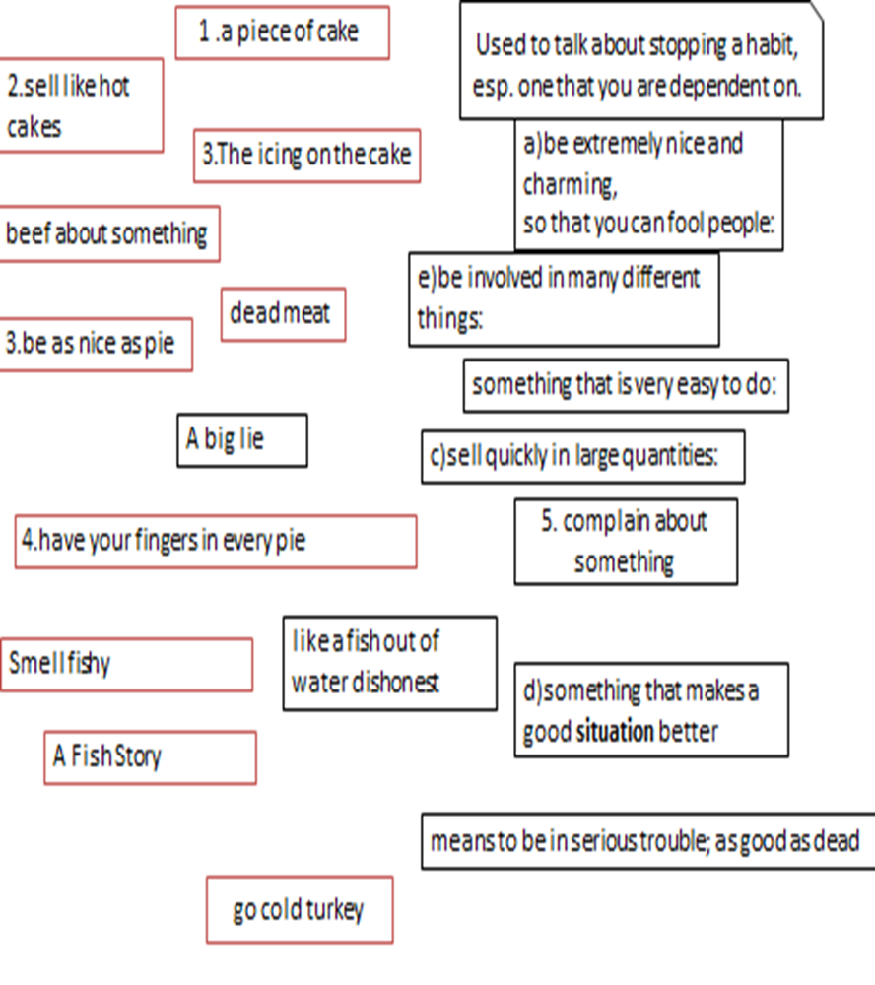
a lemon A vehicle that doesn’t work properly-

